

# User Manual Documentation for Staff Id Module

VERSION 1.0.0

DATE: AUGUST 25,2025.

PREPARED BY: PHILIP MANTE ASARE

# TABLE OF CONTENTS

User Manual Documentation for Staff Id Module 1

TABLE OF CONTENTS 2

1. MAIN LOGIN PAGE 2

• Single Finger and Ghana Card Pin Login 3

• Face and Ghana Card Pin Login 4

• No Ghana Card Pin Login Use 10 Fingers to Login 6

2. EMAIL AND PASSWORD LOGIN 8

• Password Reset Modal 9

3. DASHBOARD 10

4. ONBOARD EMPLOYEE PAGE 13

• Face Verification 14

• Single Finger Onboarding 16

• Multi Finger Login 17

• Save Employee or Person Page 19

5. MANAGE EMPLOYEE ROLES 20

• Creating a new Role 21

• Editing an existing Role. 21

• Deleting a job role 22

6. ENTRANCE MANAGEMENT 23

• Creating Entrances 24

• Editing an Entrance 25

• Deleting an Entrance 26

7. ENTRANCE DEVICES MANAGEMENT 27

• Create new Device 28

• Edit a Device 28

• Delete a device 30

8. ROLE ACCESS CONFIGURATION 30

• Assigning Day and Time Access 32

• Assign Custom Entrance 34

• To Assign A Time Rule 36

# **MAIN LOGIN PAGE**

Main login page when the application runs has three ways you can login into the system with and they are

* Single Finger and Ghana Card Pin Login.
* Face and Ghana Card Pin Login.
* No Ghana Card Pin Login use 10 fingers to login.

**NB: To be able to successfully login using any of the fingers you need to have Orbis running on your machine to be able to use KOJAK Scanner.**

Img.01

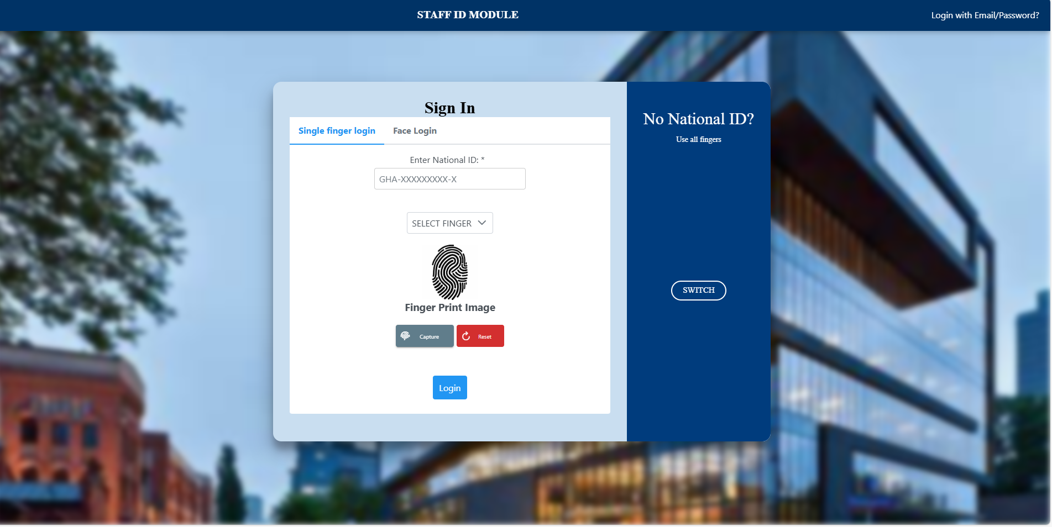

**This is the first interface you see when you login**

## Single Finger and Ghana Card Pin Login

This login allows you to login in using any finger and your national Id.

1. In the first text box you enter you national Id (Ghana Card Number)
2. You select the finger you want to login with. eg: Left Index, Right Thumb when you click on the dropdown showing select finger.
3. Press On the Capture button, ensure you have selected the finger you want to login in with before pressing capture and wait for the fingerprint scanner (Kojak) to beep and place selected finger on the Kojak.
4. After finger has been captured successfully the fingerprint image would show above fingerprint Image text.
5. When the finger is captured successfully a notification would pop up informing you finger has been captured successfully.
6. Press on login to access the application.

## Face and Ghana Card Pin Login

Img.02

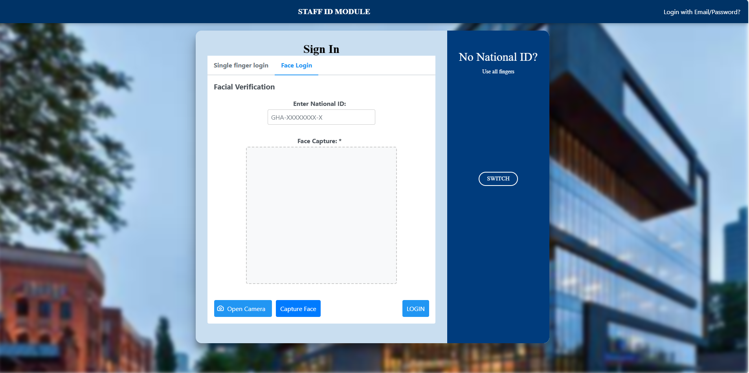

This login can be used in place when a fingerprint is not available at the moment.

1. To use face login, click on the Face Login Tab to see the face Login Interface.
2. Enter Ghana Card Pin and click on open Camera to allow access to use webcam.
3. Look at the web cam and click on the capture Face button like shown in image (img.03) below
4. Position the blue outlined square that shows to fit your face and click on login.

Img.03

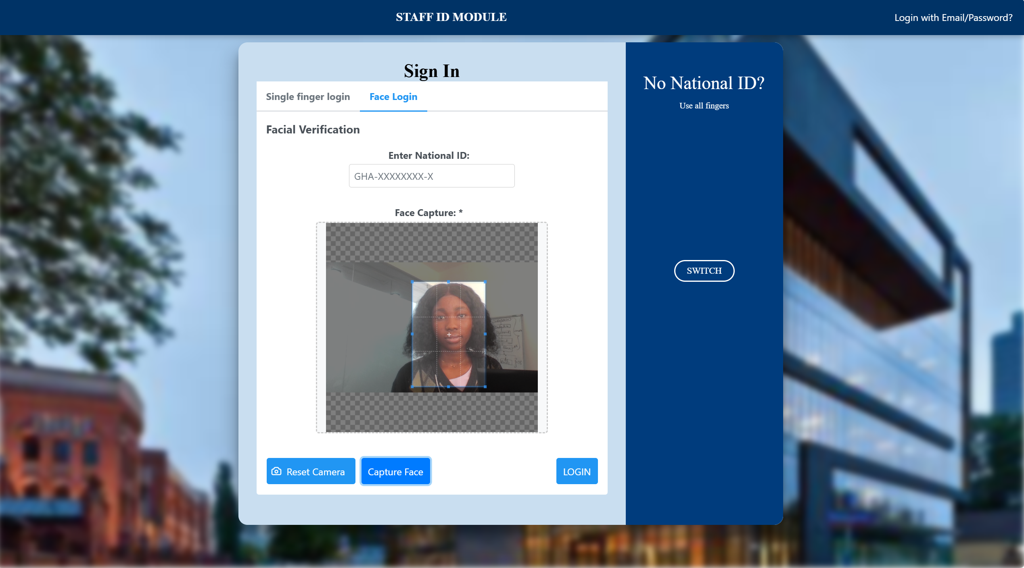

## No Ghana Card Pin Login Use 10 Fingers to Login

This allows users who don’t know their Ghana Card Pin and don’t have their Ghana Card at that moment to login with all 10 fingers using the fingerprint Scanner (Kojak).

1. To use this method of login click on the switch button to change to the No Ghana Card Login interface.

***Img.04***

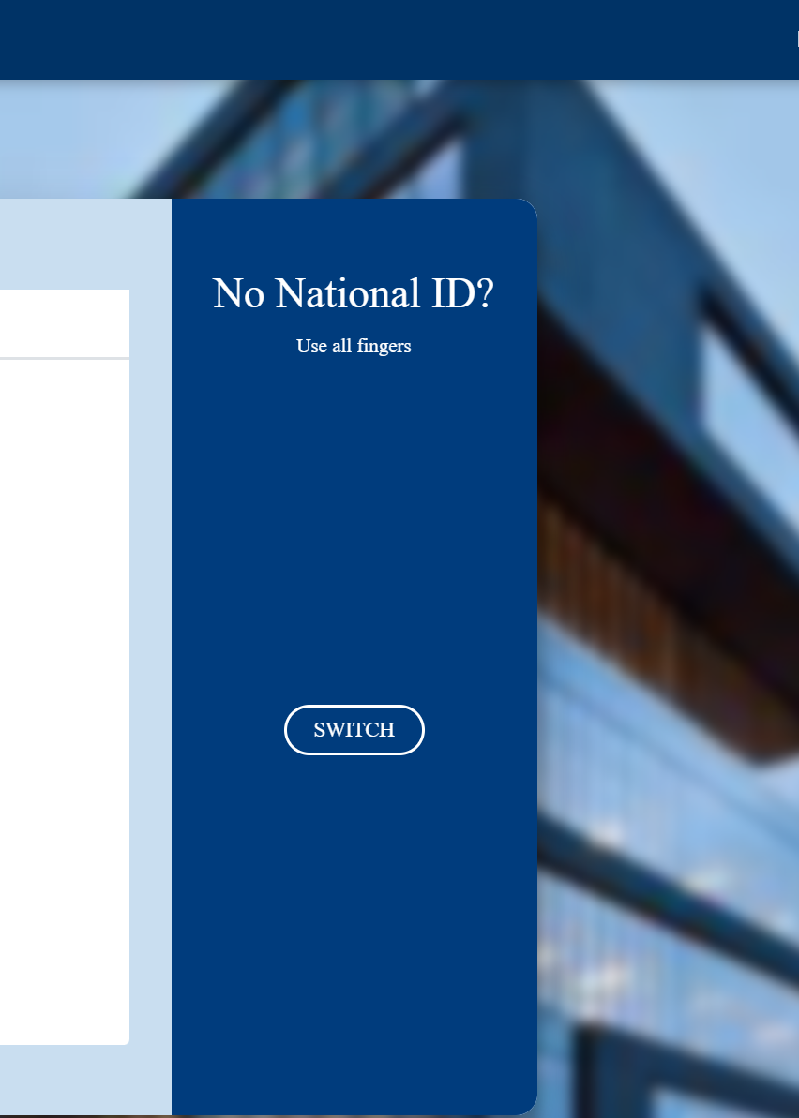

2.The interface would show as shown in Img.06.

***Img.06***

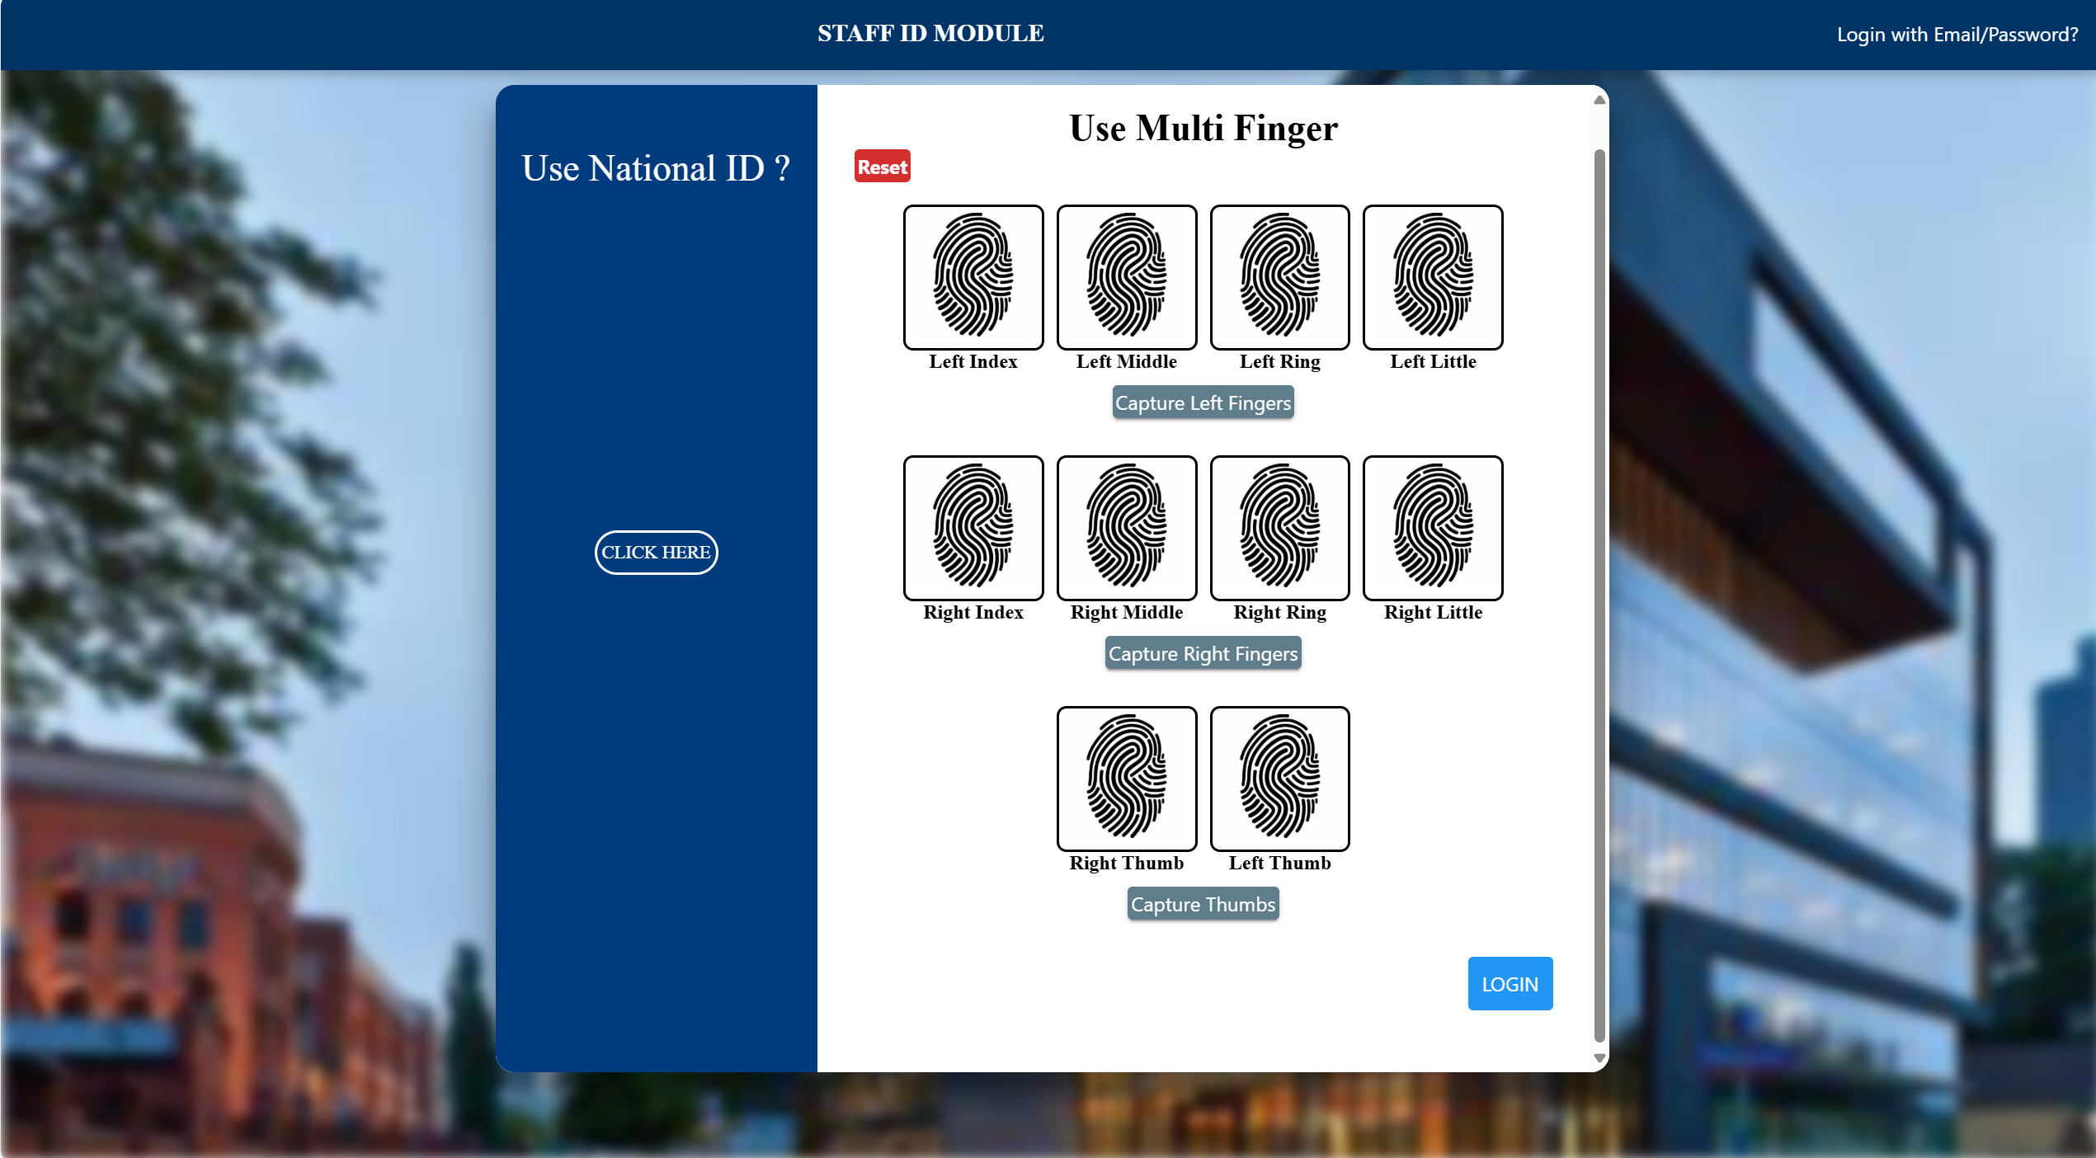

1. Click on the Capture Left Fingers button and wait for the fingerprint scanner to beep.
2. When it beeps place the indicated fingers above on the fingerprint scanner.
3. Repeat the same for the capture Right Fingers button and capture thumbs button and place the required fingers on the fingerprint scanner after the beep.
4. Scanned fingerprint images would show after successful scans then, click on the login button.

**NB: You can click on the reset button to restart your process when you make a mistake during capturing of biometrics.**

# **EMAIL AND PASSWORD LOGIN**

**This page allows you to login with your email and password.**

1. Click on the Login with Email Link at the top right corner.

*Img.07*

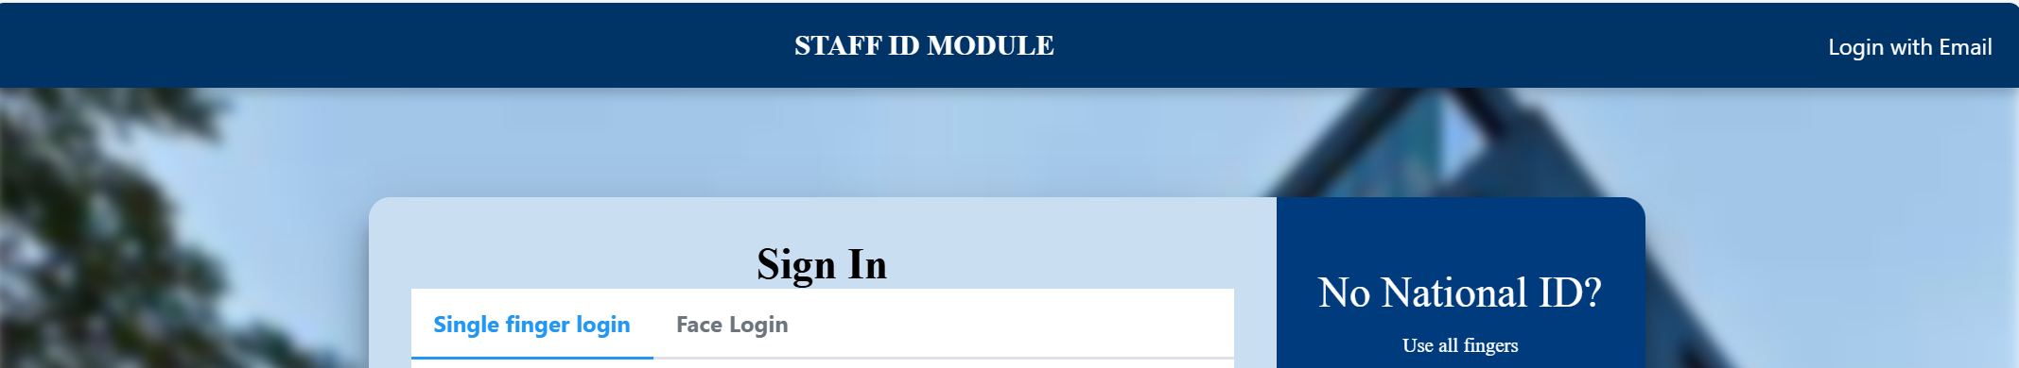

2. Enter your email.

3. Enter your password.

4. Click on login

**The email and password login page.** ***Img.08.***

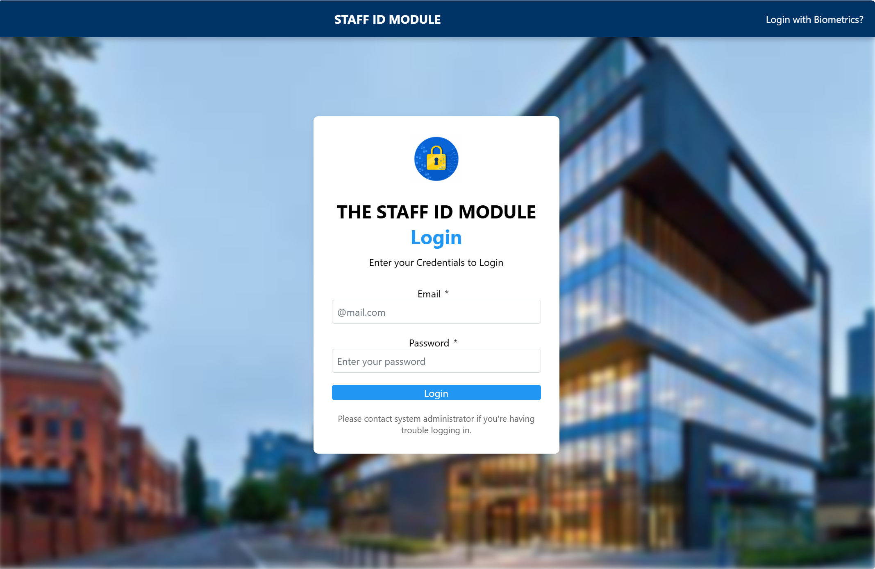

## Password Reset Modal

**NB: If it is your first time logging in after admin has created an account for you, you would be prompted to change your password as shown in image img.09.**

***Img.09.***

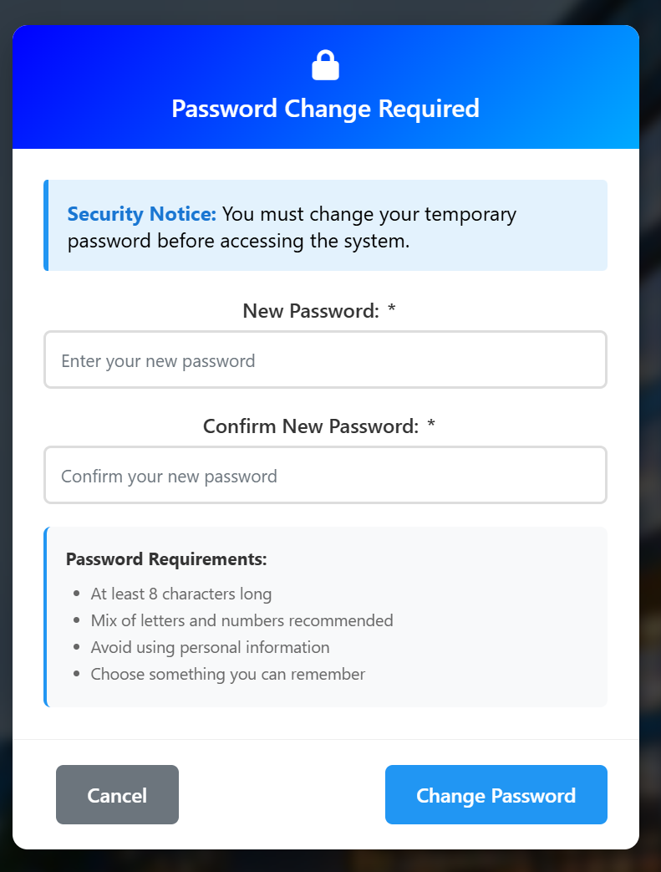1

**1.Enter the new password you want to use (Ensure it meets the requirements stated below in the image)**

**2. Enter it again to confirm it**

**3. Click on Change Password.**

**4. You are sent to the dashboard page.**

# **DASHBOARD**

This page shows the content of the system. This is the first page you see when login is successful, it varies based on the User Type.

*Img.10.*

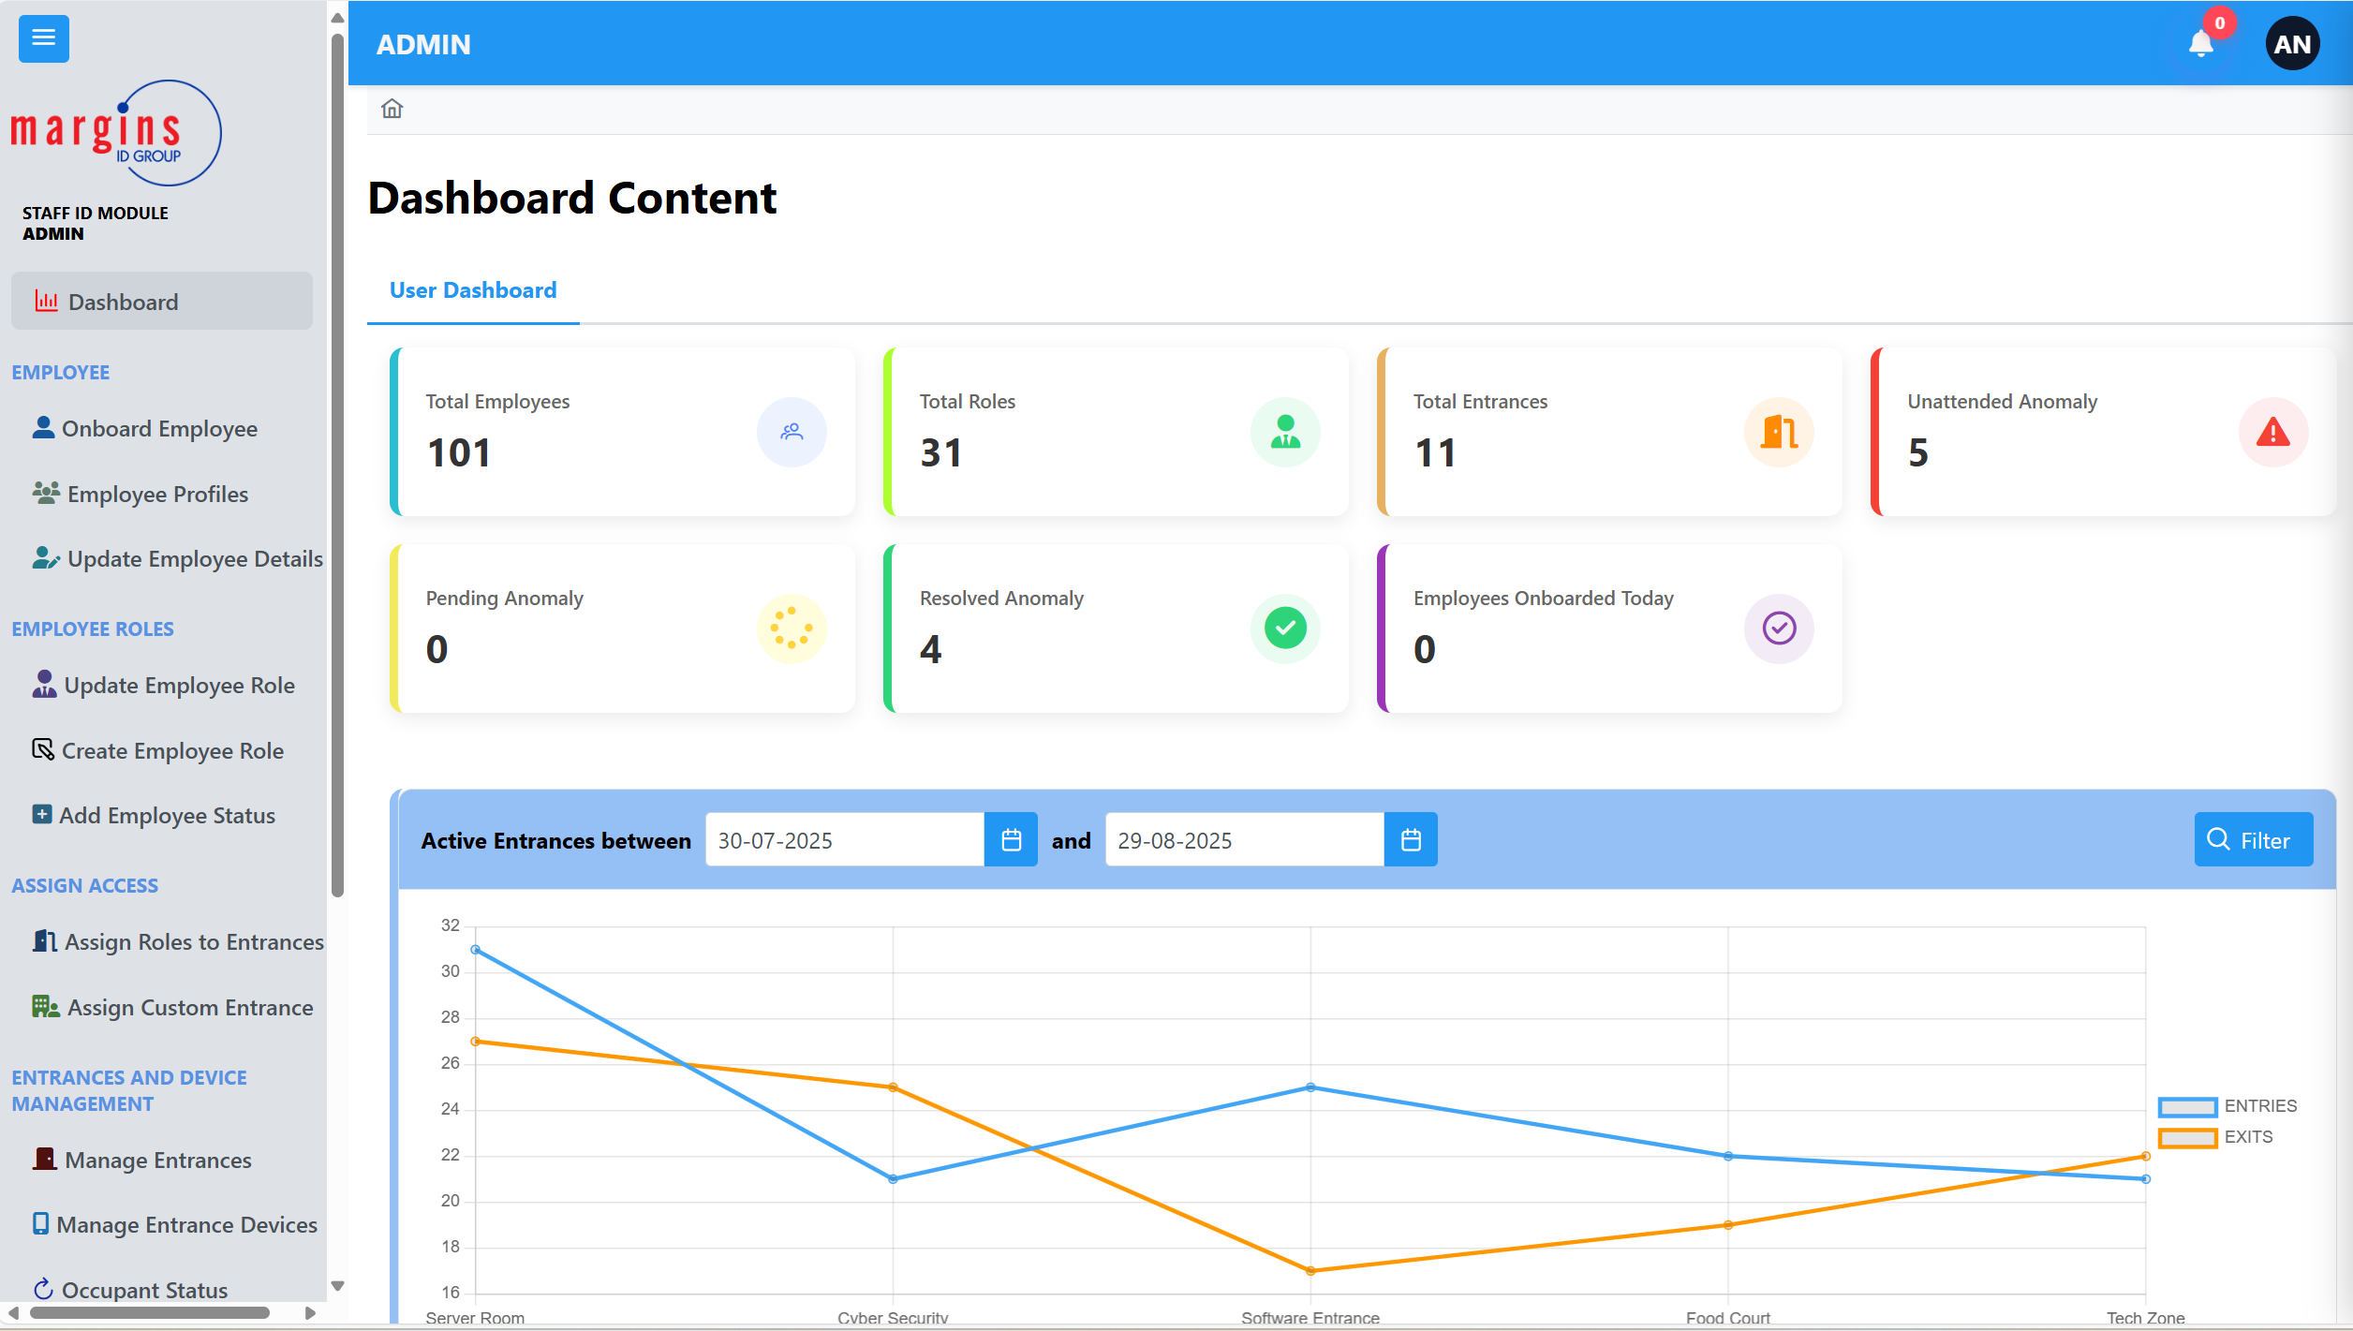

The dashboard has clickable cards that show the current counts shown on the cards in image img.10.1

*Img.10.1*

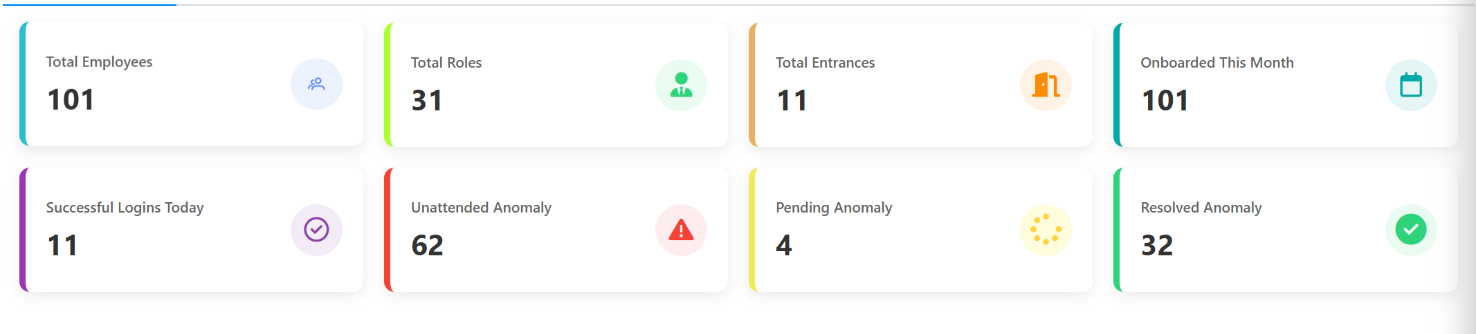

*Img.10.2*

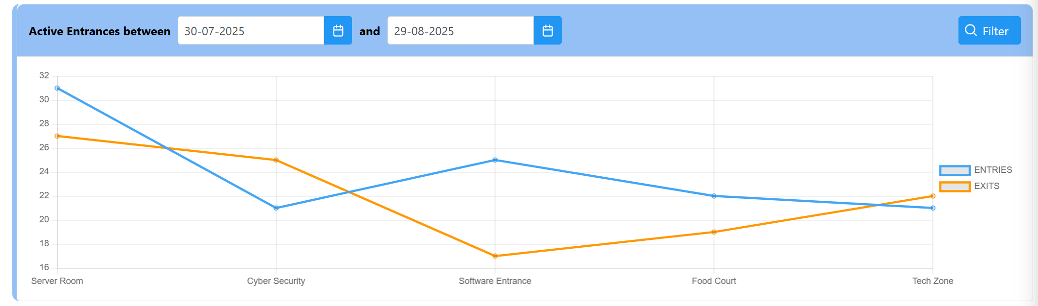This Chart shows you a trend of the top 5 active entrances between the selected days as shown in img.10.2.

*Img.10.3.*

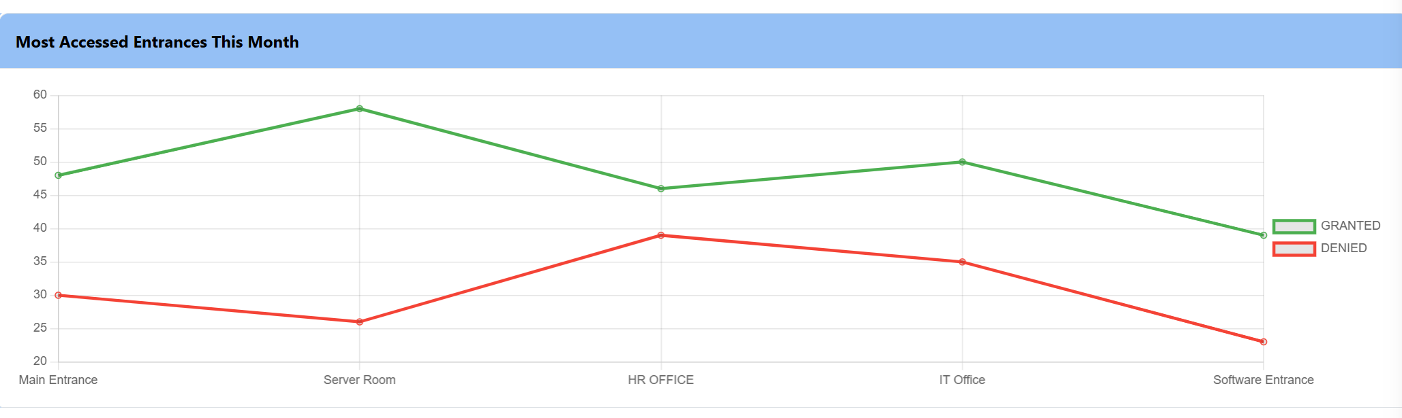

This shows the active entrances in the previous month on the dashboard as shown in img.10.4.

This shows the recent access in real time

*Img.10.4.*

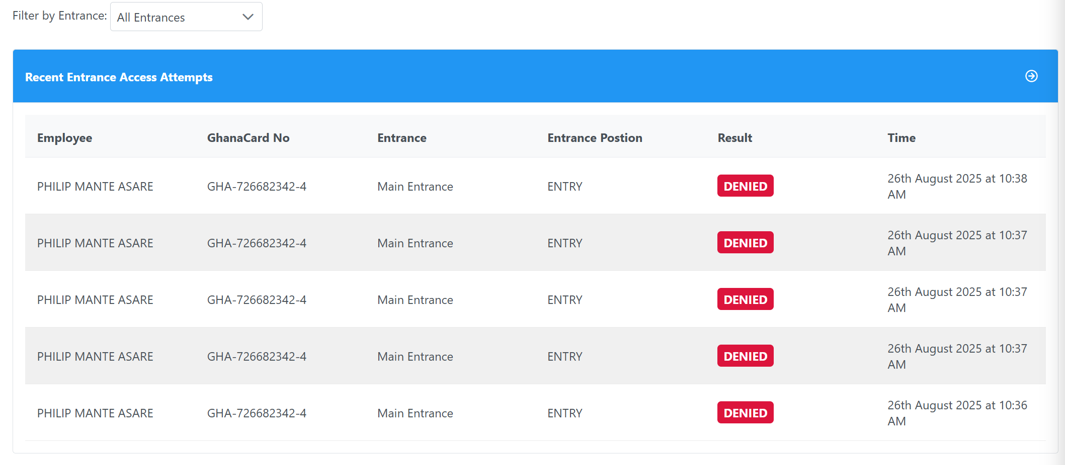

# **ONBOARD EMPLOYEE PAGE**

***Img.11.0.***

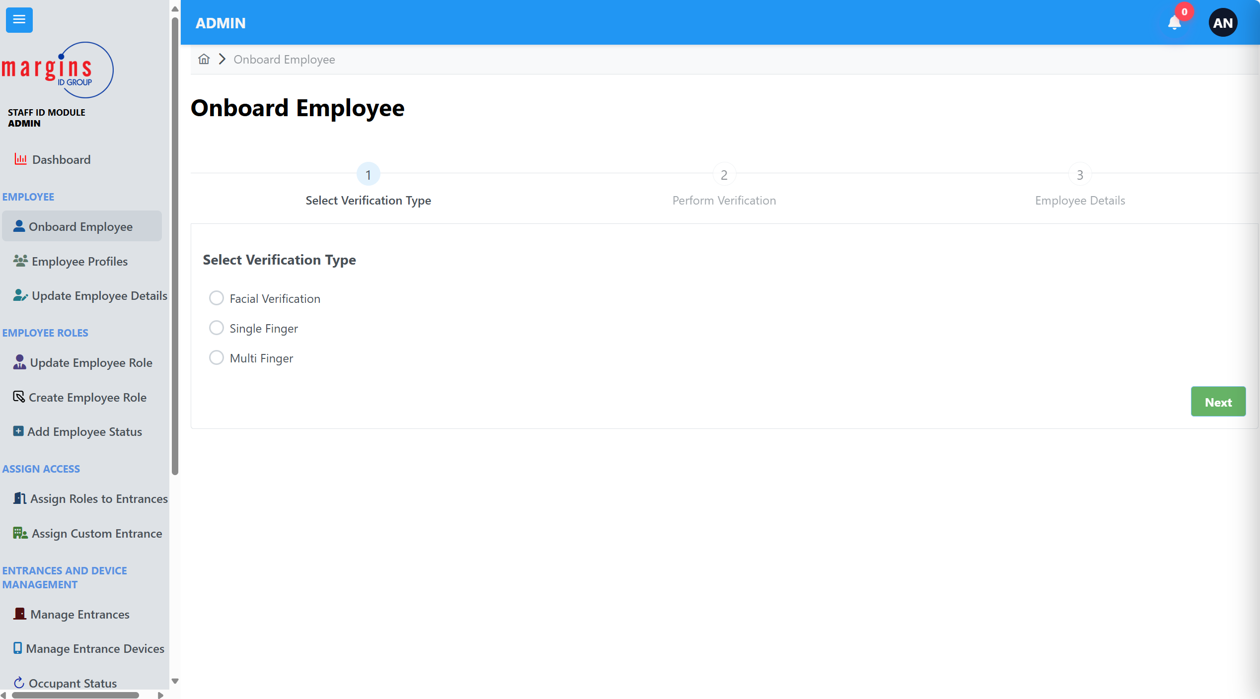To access this page on the sidebar click on the Onboard Employee tab, this page allows you to add new employees to the system.

There are three ways to onboard employees into the system

1. Face Verifcation
2. Single Finger
3. Multi Finger.

To use any of these verification methods you select the one you prefer and click on next.

## Face Verification

When you click on face Verification this page shows as below in img. 12.0.

*Img.12.0*

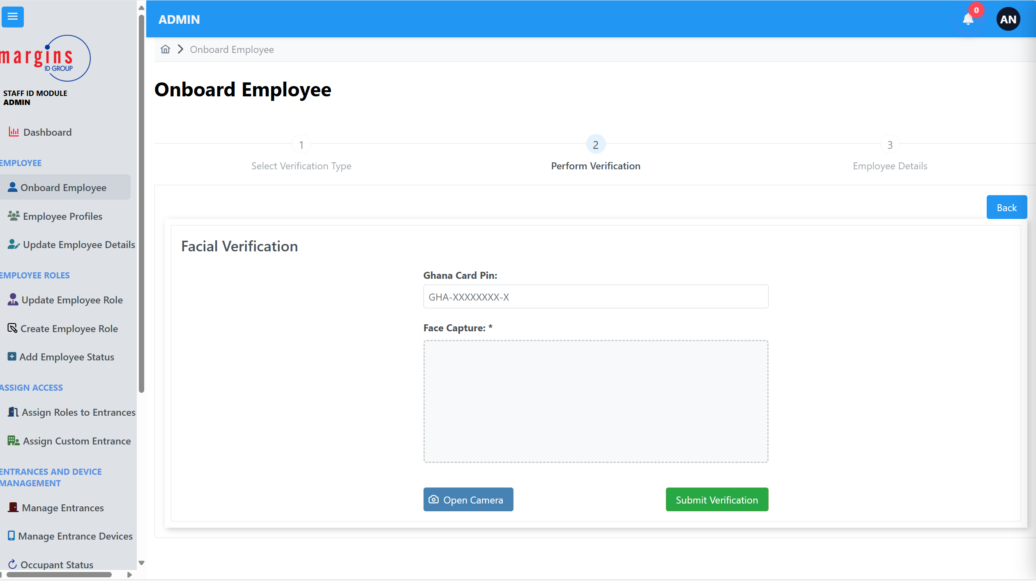

***HOW TO ADD A NEW EMPLOYEE WITH FACE VERIFICATION***

1. On this page enter your Ghana Card Pin in the Ghana Card Pin textbox shown.
2. Click on the Open Camera Button.
3. Position your face and in the center and click on capture as shown in img 12.1.

*Img.12.1.*

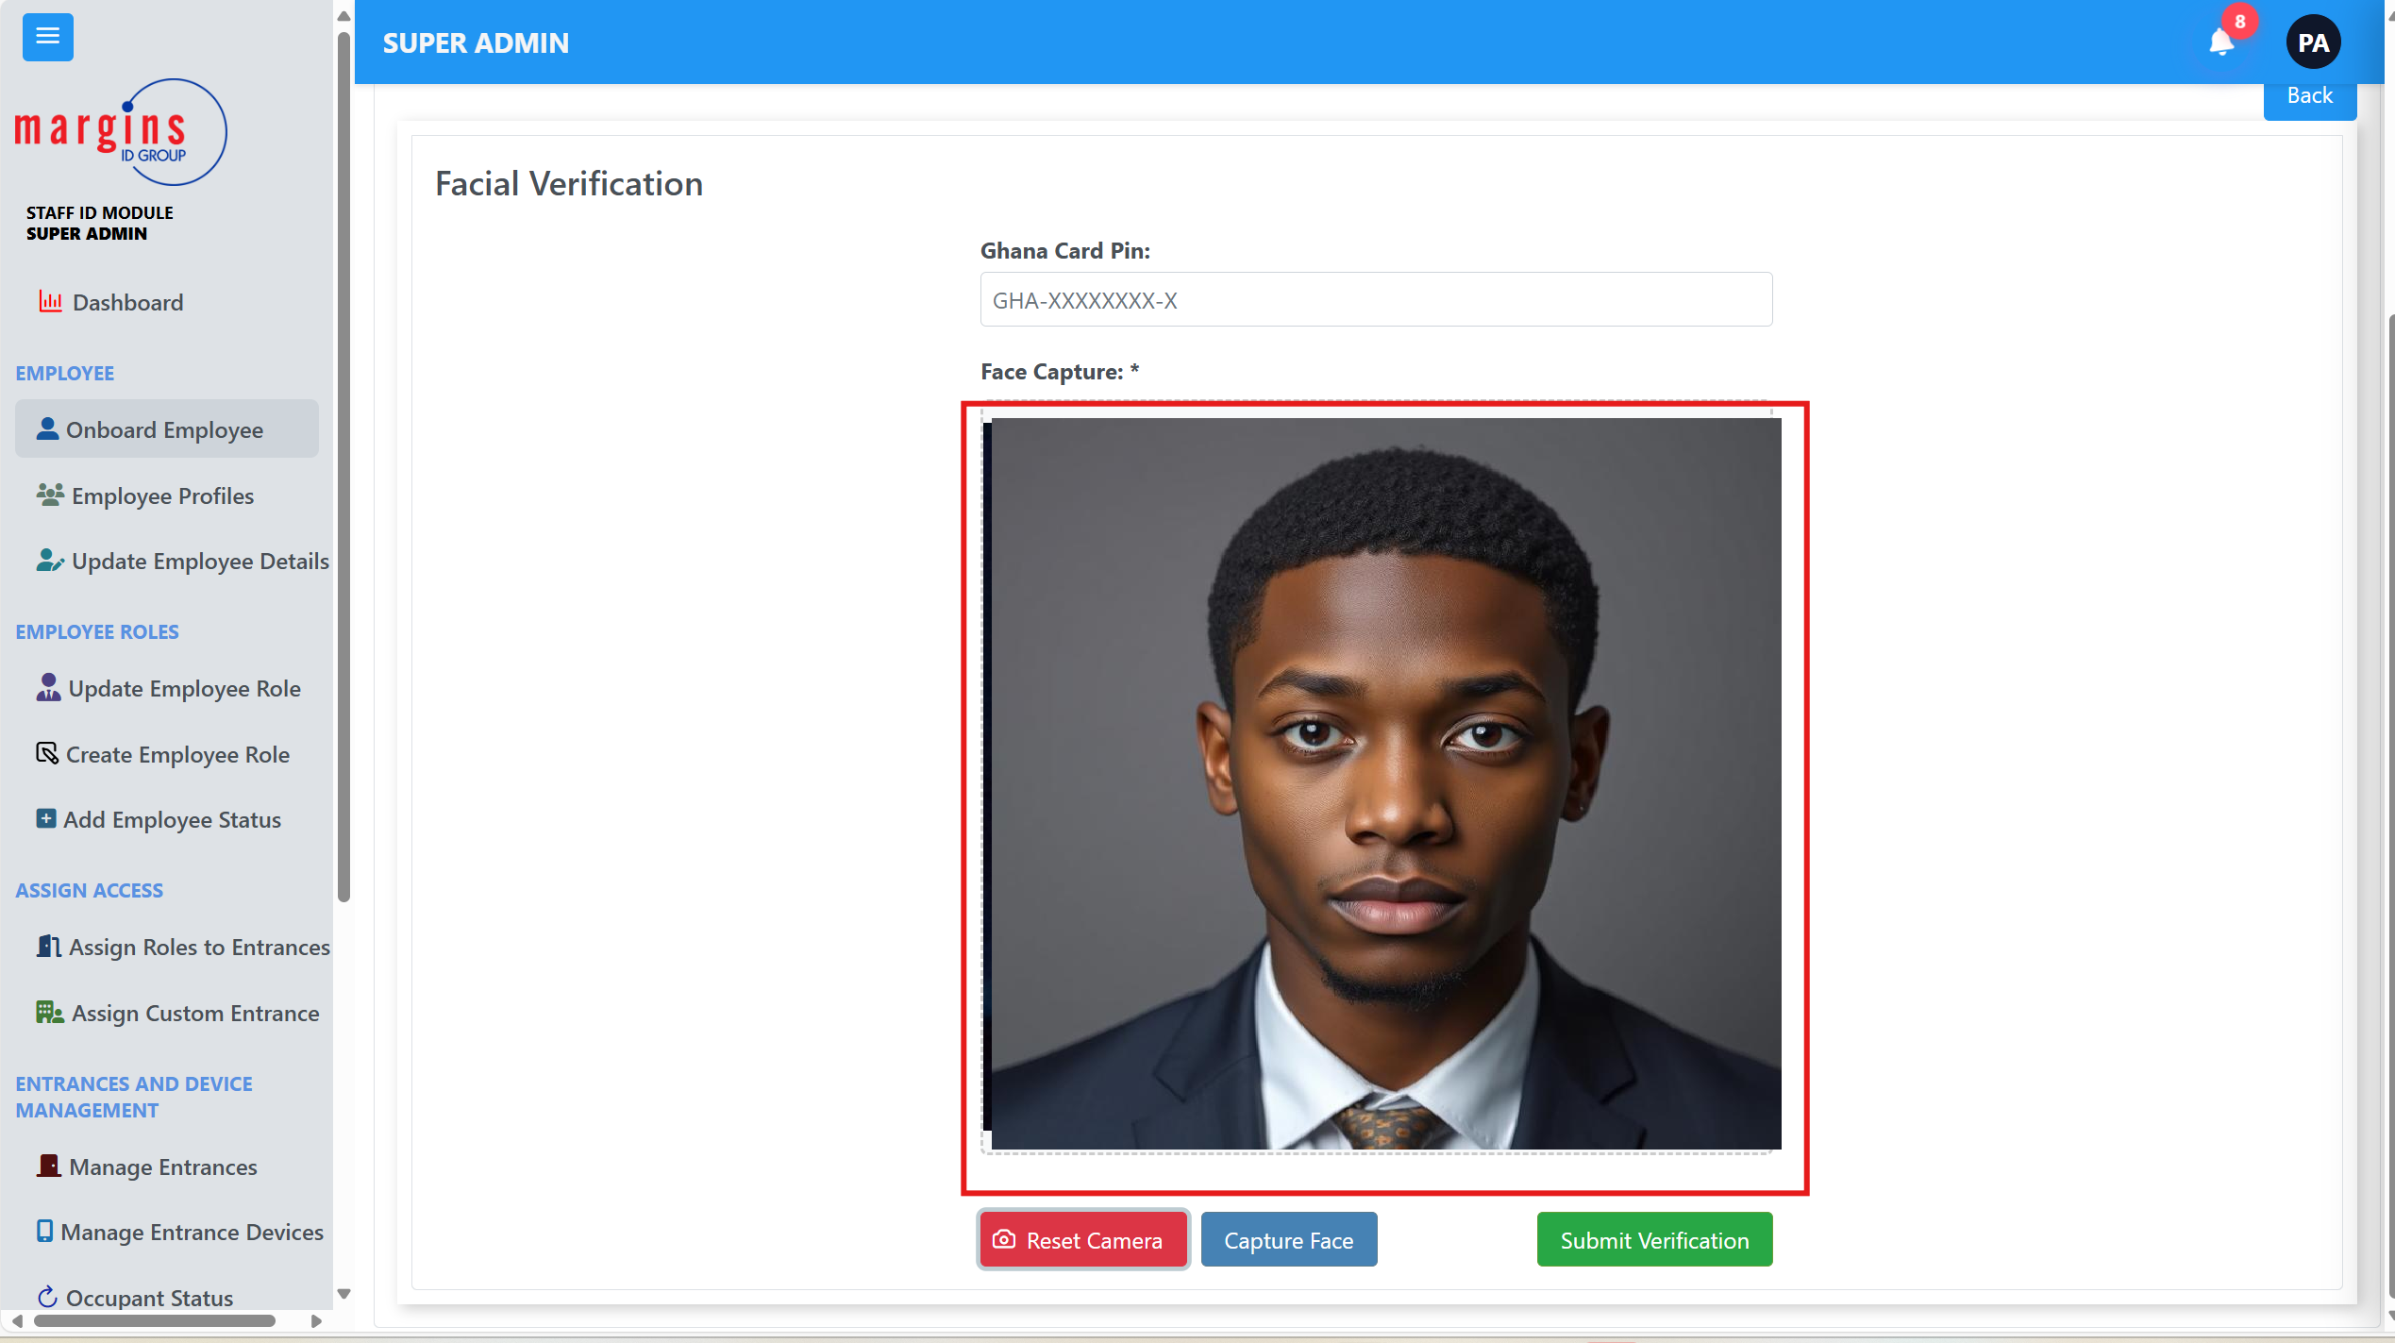

4.Click on the capture button

5.Click on the blue outline and move it to the center of your face.

*Img.12.2.*

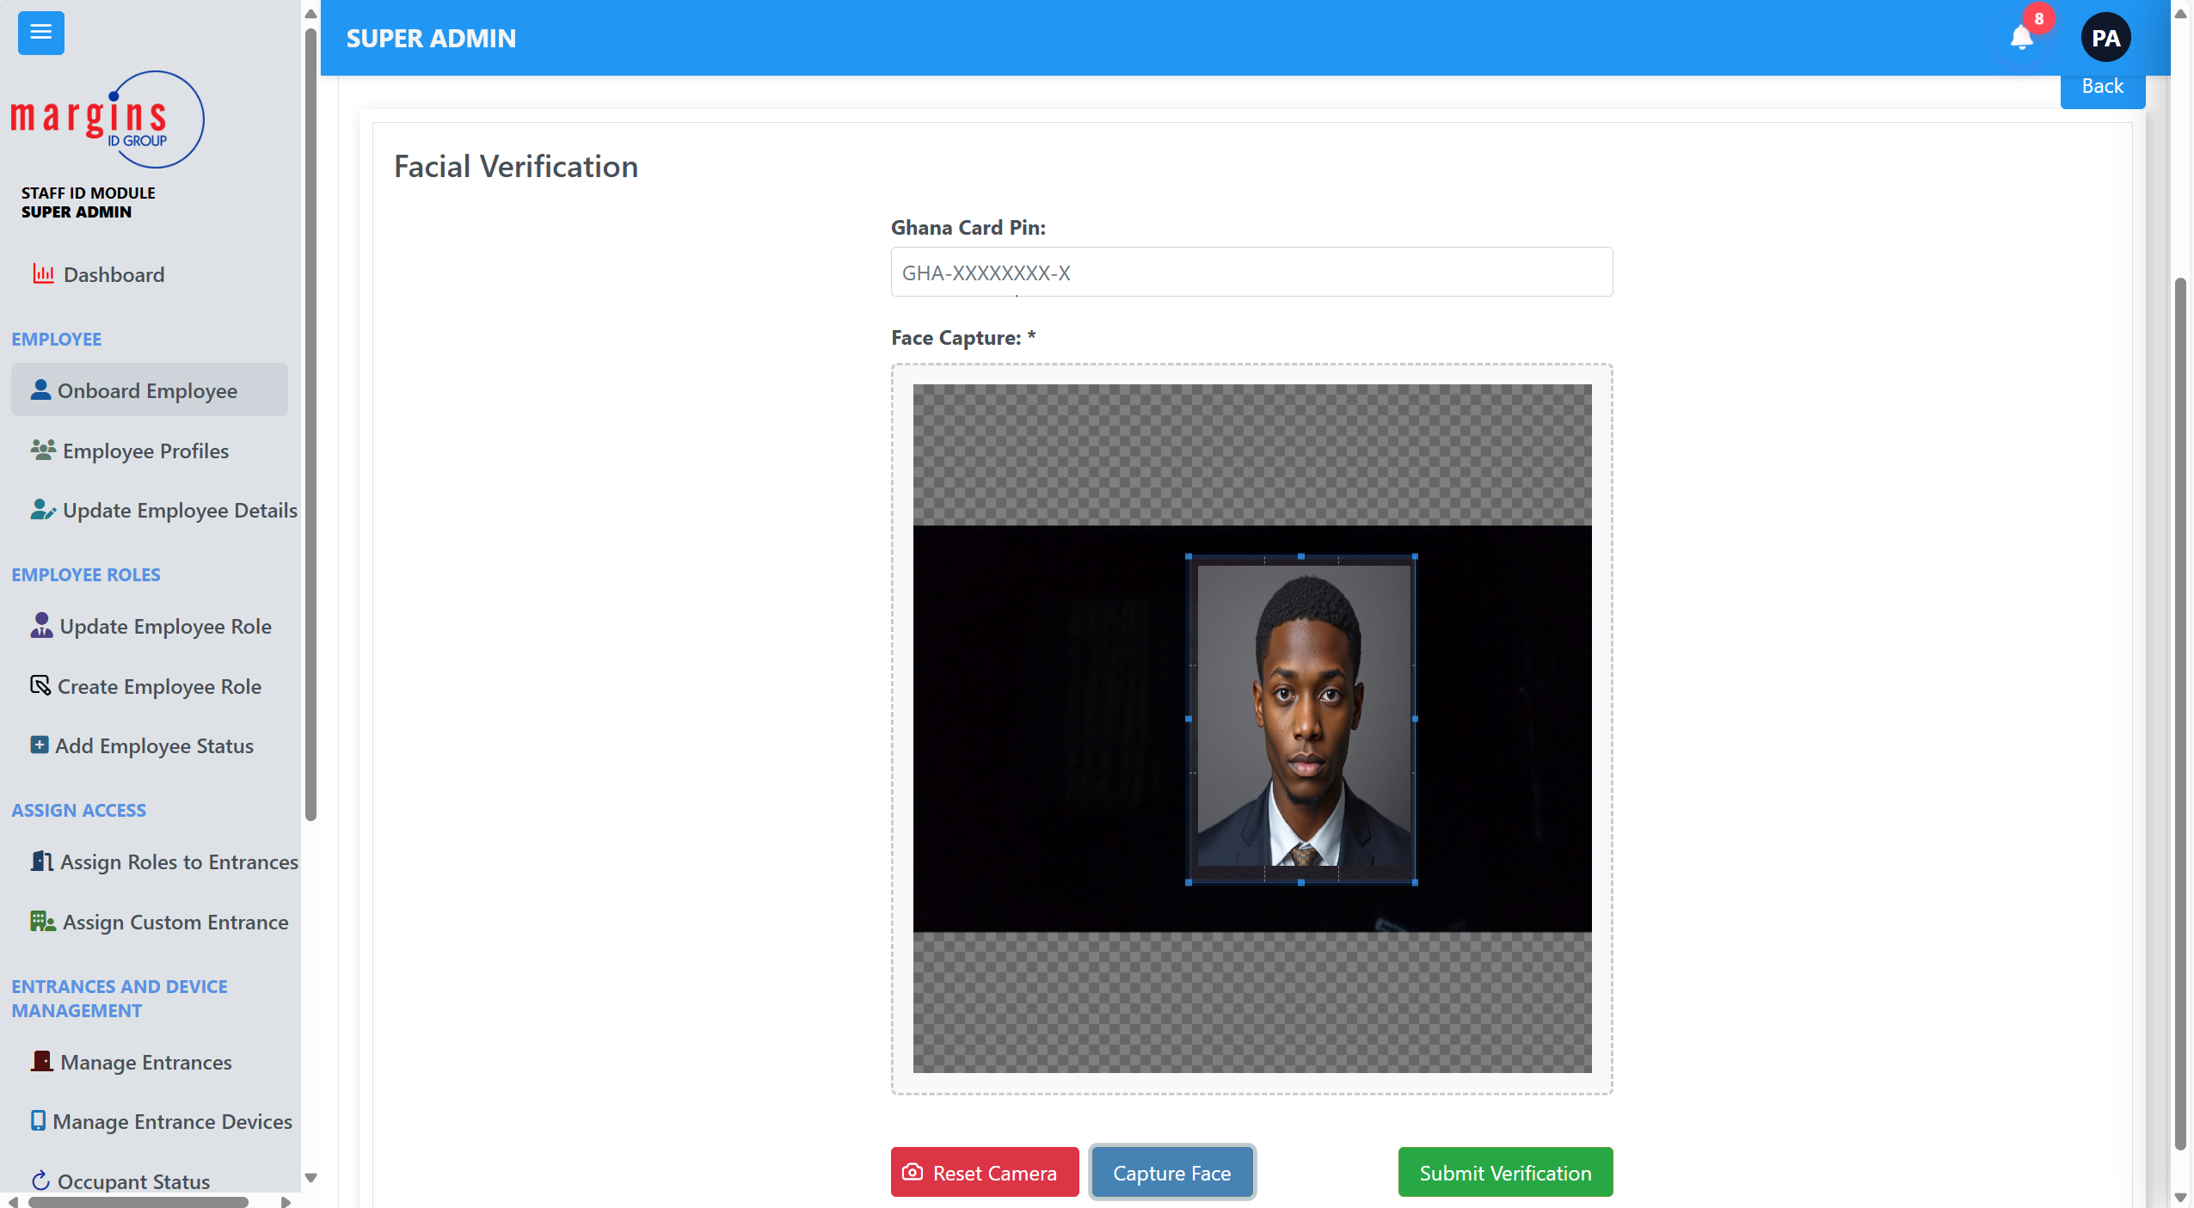

1. Click on Submit Verification.

## Single Finger Onboarding

**NB: To use this process of adding a new user you need to have a kojak scanner available and connected.**

1. On the onboarding page click on Single Finger and then click next.
2. Enter your Ghana Card Pin and select a finger you want to scan it with.

**Img 13.0.**  
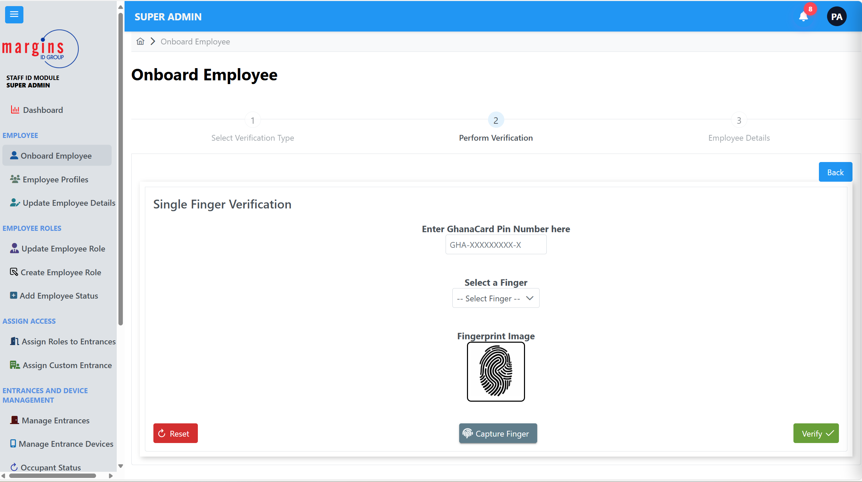

1. Click on the capture Button and wait for a beep from the kojak scanner.
2. When it beeps put the finger you selected on the scanner.
3. When scan is complete click on verifiy

## Multi Finger Login

1. Select multi finger on the first page you see when you click on the onboarding page.

A new display would show as shown in img 14.0

**NB: Ensure you have your kojak fingerprint Scanner connected**

Img 14.0.

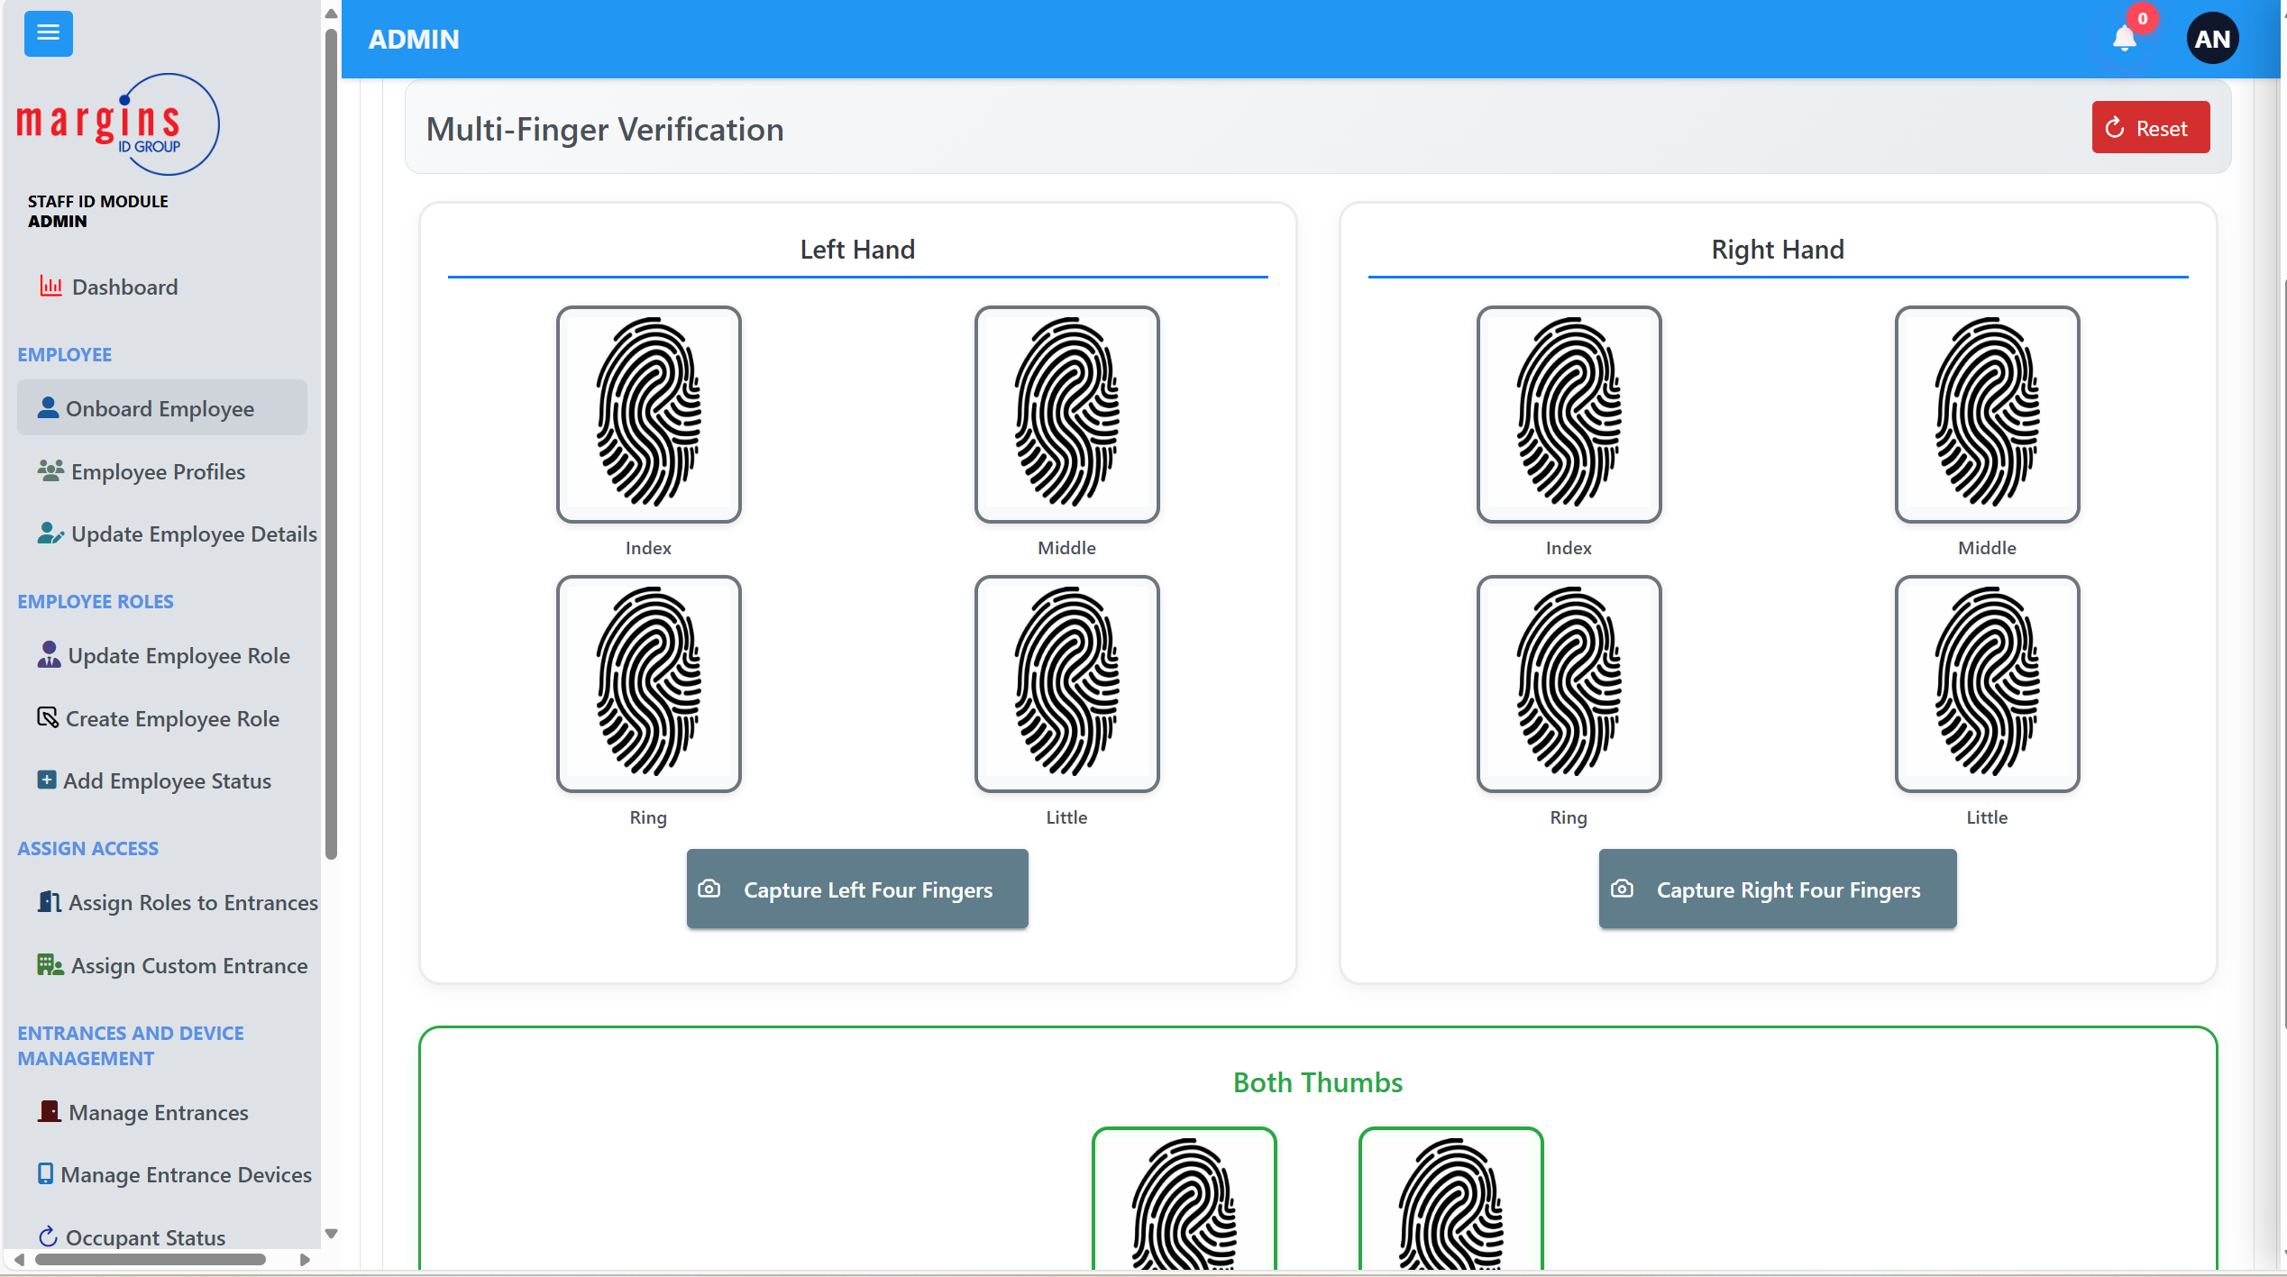

1. To start click on capture left four fingers button and wait for the kojak scanner to beep
2. When it beeps place your four left fingers excluding your thumb on the scanner.
3. When it’s done the scanned fingerprint would show on the page.
4. Repeat the same for when you click on Capture Right four fingers, this time use put your right fingers excluding your thumb on the device.
5. Scroll up the page to view the section to scan the thumbs as shown in img 14.1.

Img 14.1.

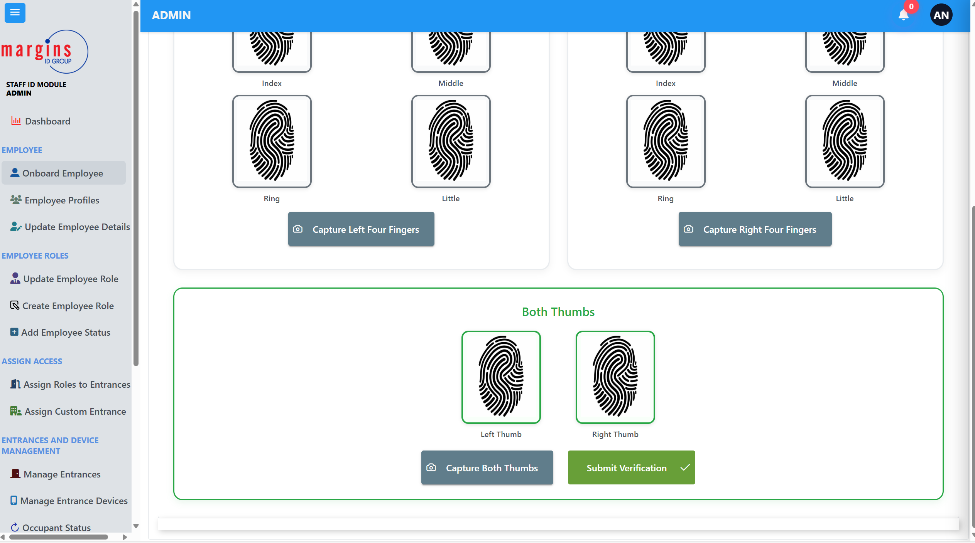

1. Click on the capture thumbs button and wait for the kojak to beep
2. Put both left and right thumbs on the scanner and wait for it to beep again to confirm it is done.
3. Click on Submit Verification.

## Save Employee or Person Page

**This is the final step in the onboarding process. It goes to this step after verification is successful .**

**The page shows the face image and details of the person you verified.**

**Img 15.0.**

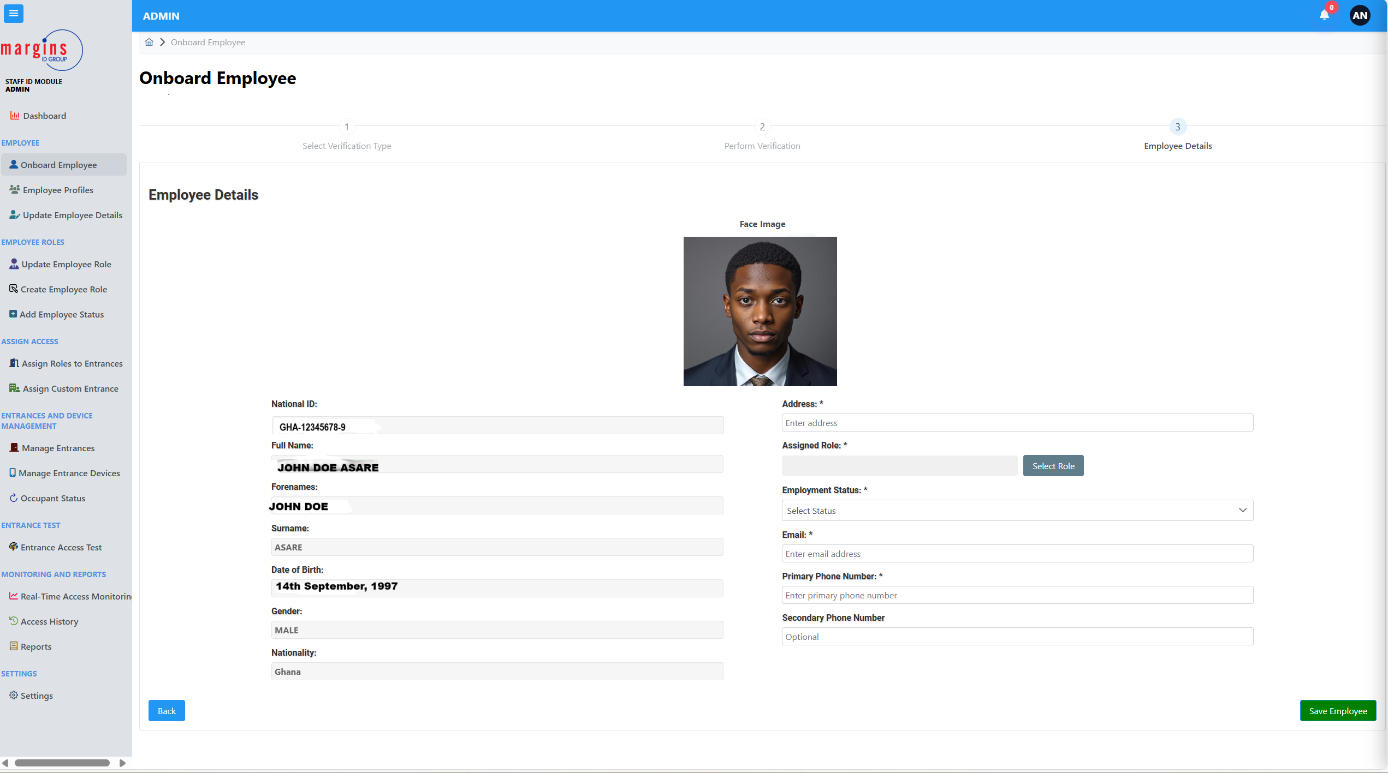

**To save an employee successfully**

1. Enter the employee’s current address
2. Click on the assign role button to assign a job role to the employee
3. Select an employment Status for the employee.
4. Enter the employee’s email.
5. Enter the employee’s phone number
6. If there is another phone number, you can enter that in the secondary phone number section
7. Click on save Employee.

# **MANAGE EMPLOYEE ROLES**

To access this page, click on the create employee role on the side panel.

**Img 16.0.**

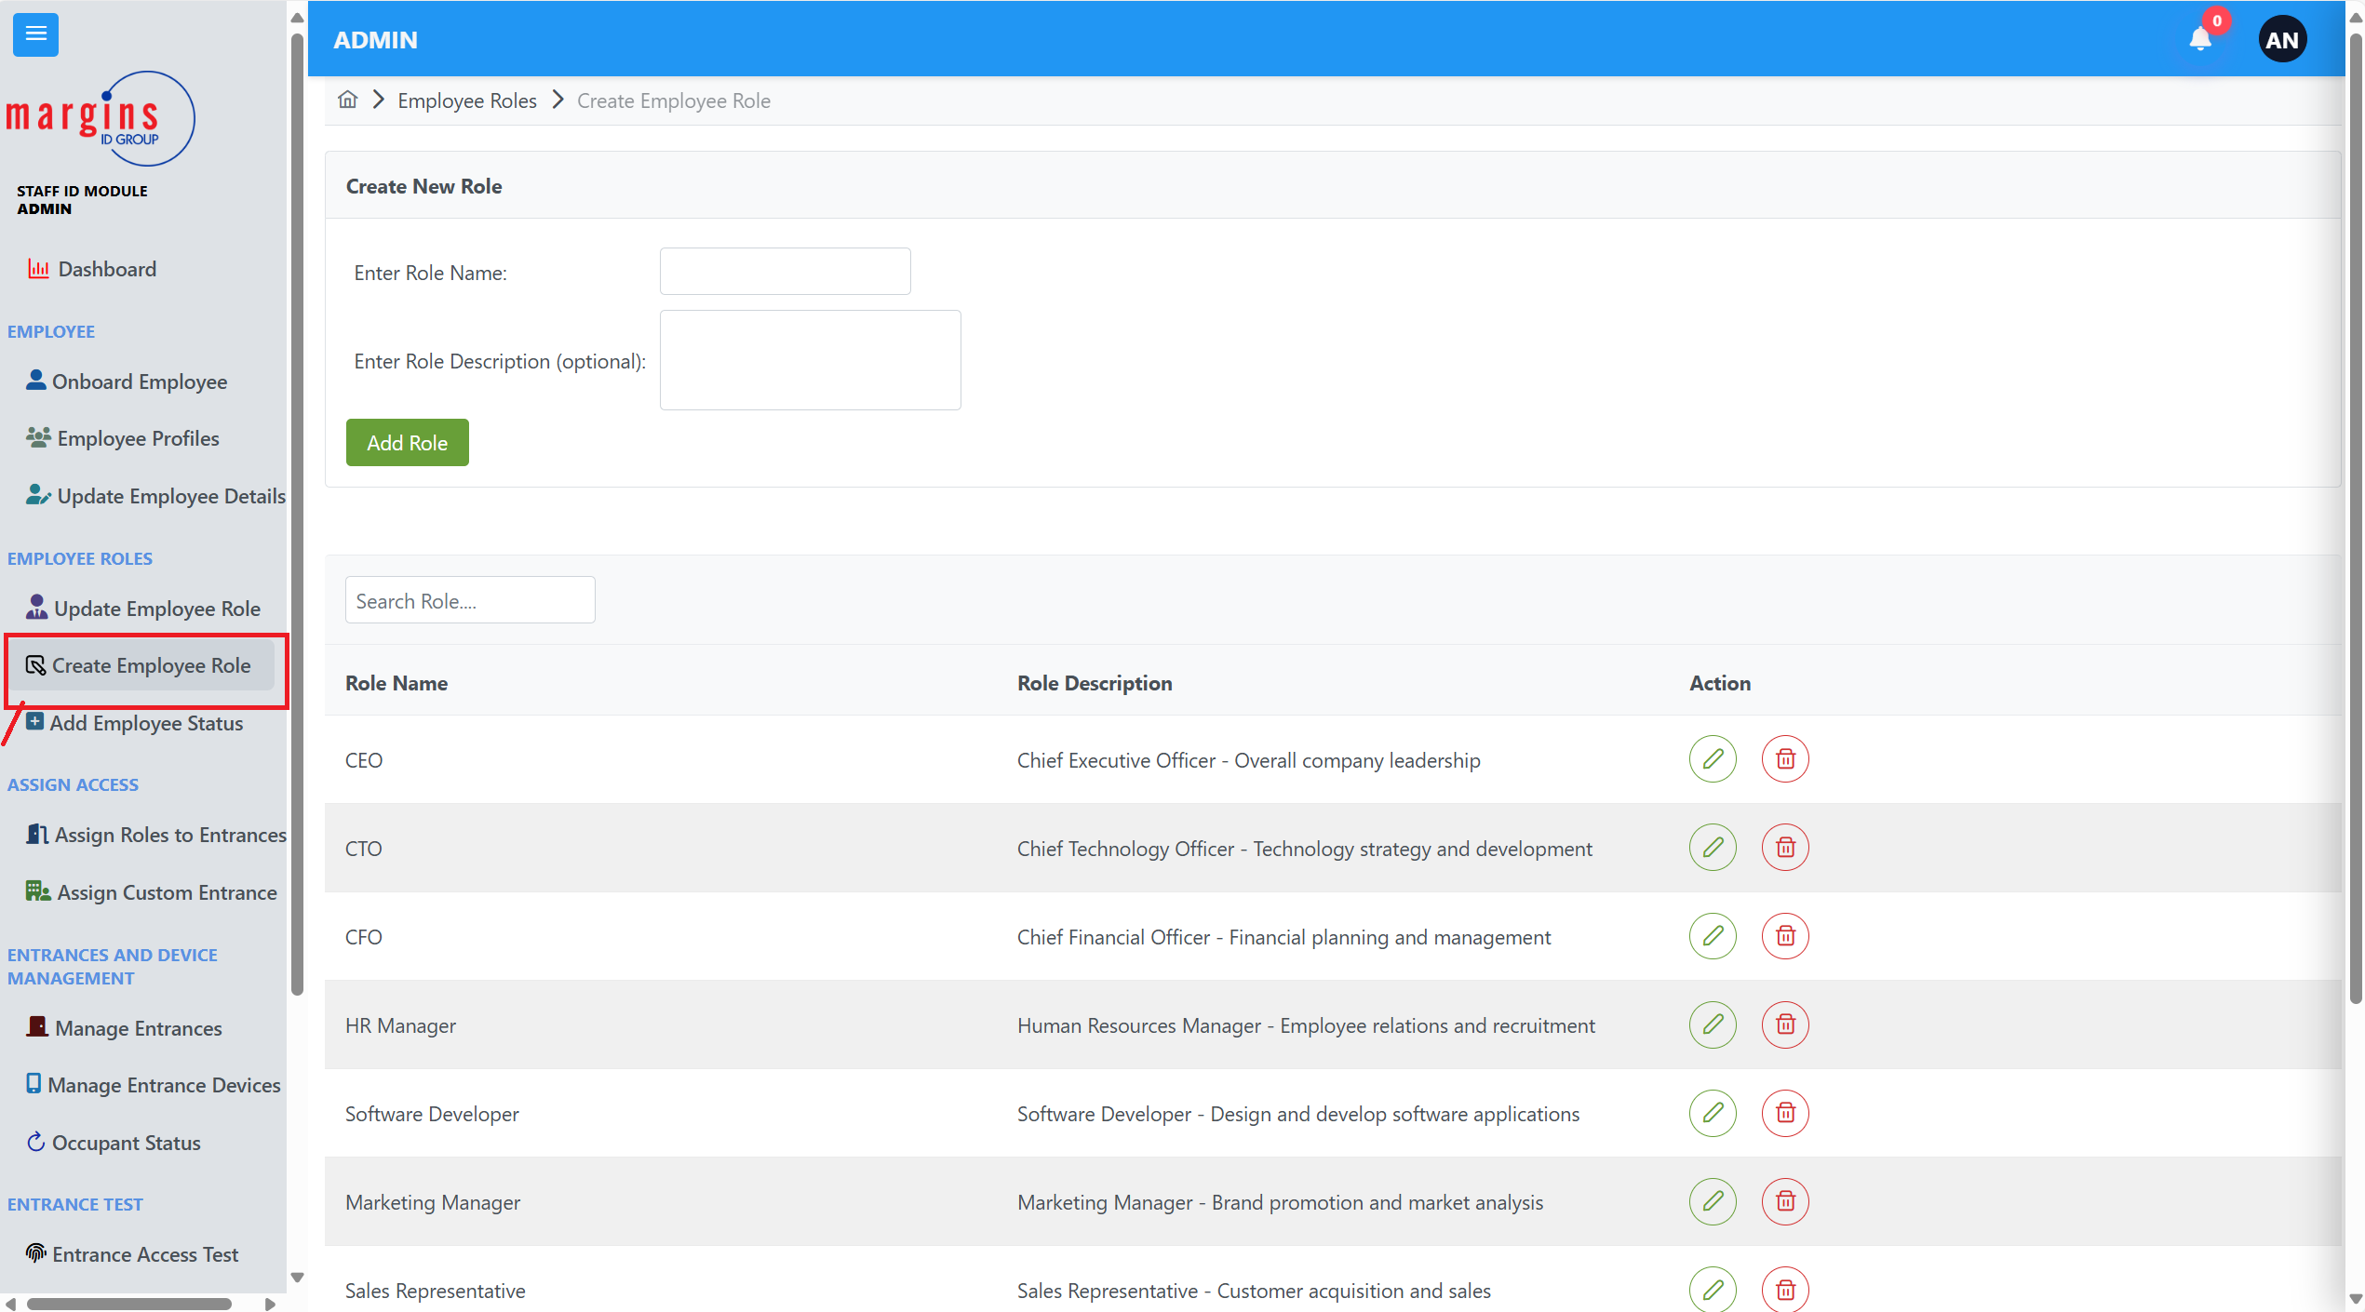

## Creating a new Role

1. Enter the name of the role you want
2. Give a brief description of the role.
3. Click on Add Role.

## Editing an existing Role.

1. Click on the pencil button as shown in image img .16.1.

**Img.16.1**

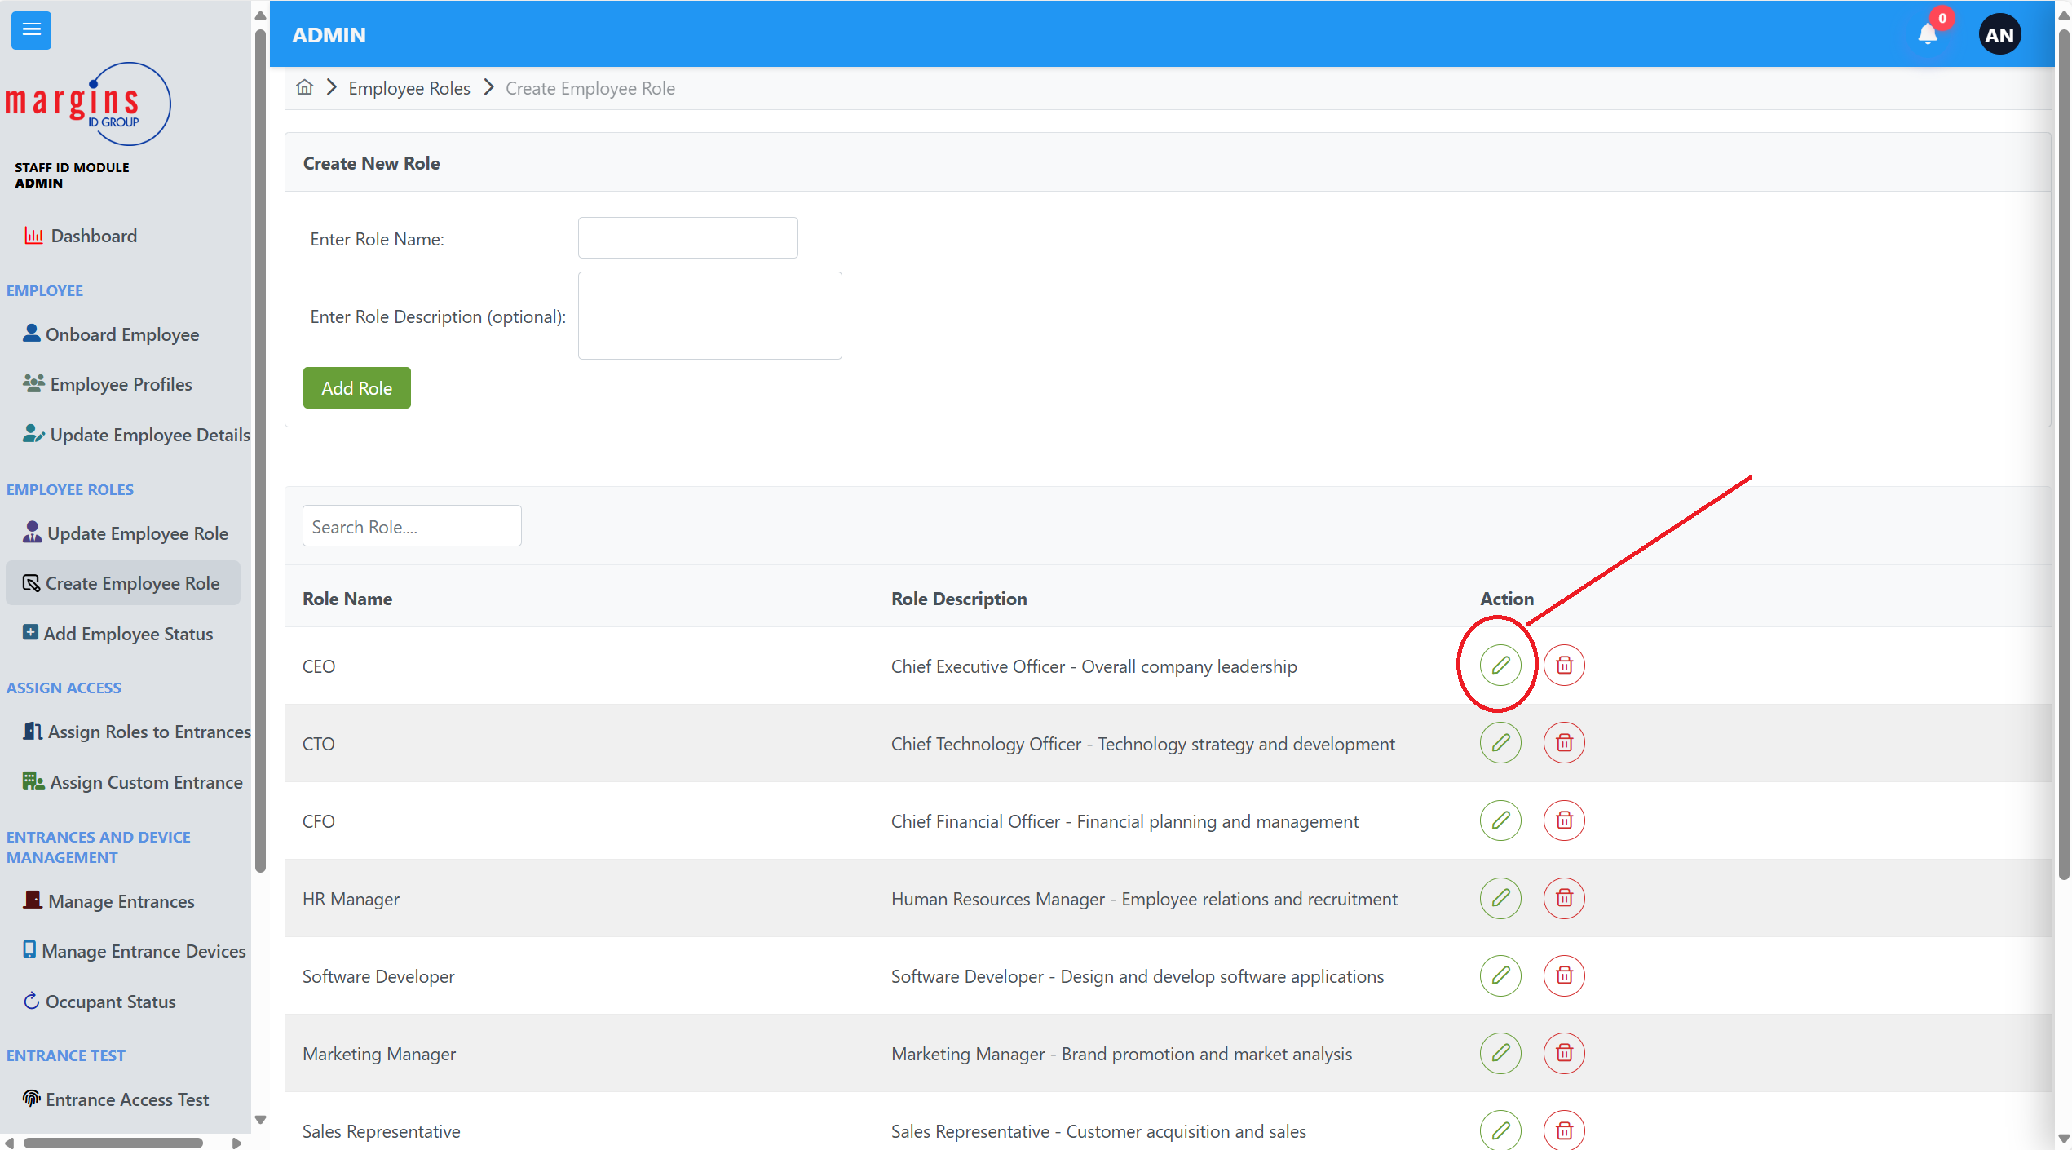

1. A pop- up dialogue would show.

**Img.16.2.**

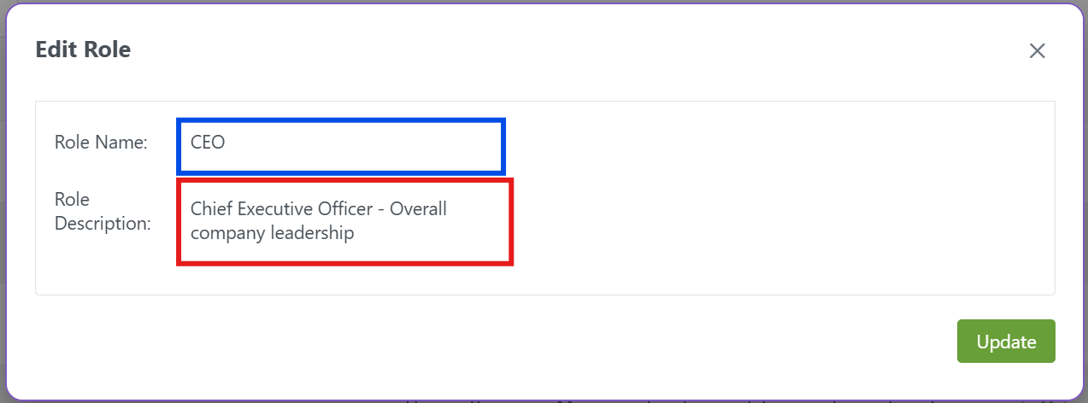

In the edit dialogue,

3.Click on the role name to edit it

4. To edit the role description, click on the Role Description dialogue outlined red.

5. Click on update to save.

## Deleting a job role

**Img. 17.0**

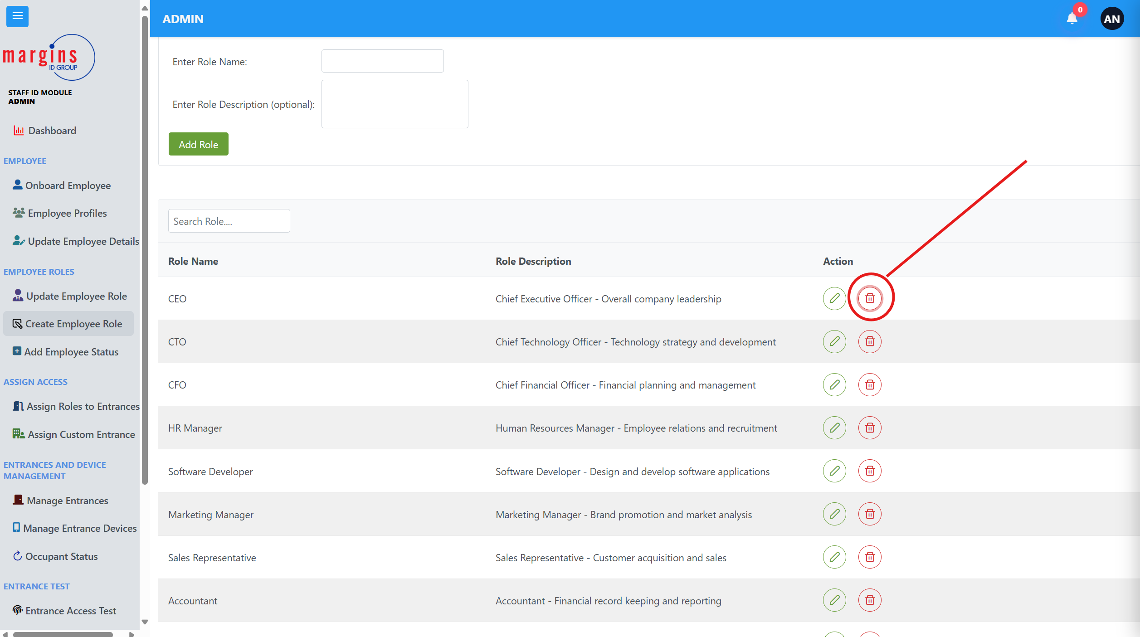

1. Click on the dustbin icon
2. A pop-up dialogue would show
3. Click on the delete button

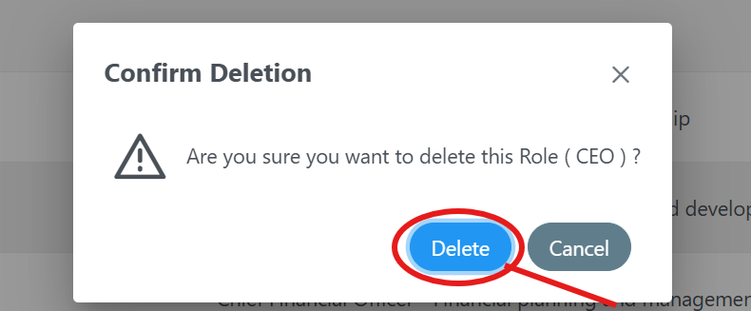

***Img. 17.1.***

# **ENTRANCE MANAGEMENT**

**This page allows you to create new entrances and assign them unique entrance id, edit entrances and delete entrances.**

***Img.18.0.***

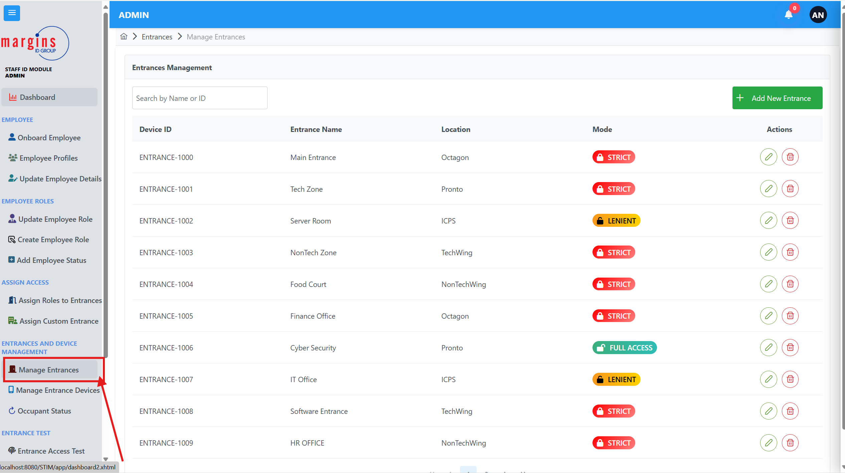

## Creating Entrances

To create an entrance, you go through these steps

1. You click on the green add entrance button
2. A pop-up dialogue would appear as shown in img 18.1.
3. Enter a unique Entrance ID.
4. Enter the name of the entrance
5. Enter the location of the entrance
6. Select a mode for the entrance
7. Click on save.

***Img.18.1***

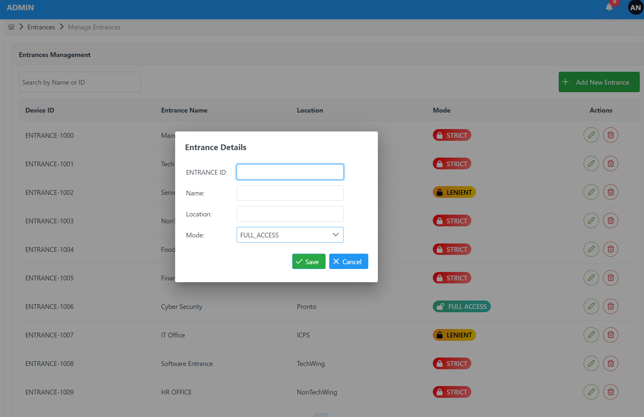

## Editing an Entrance

To edit an entrance, you click on the green pencil icon as shown in image Img.18.2.

**Img.18.2**

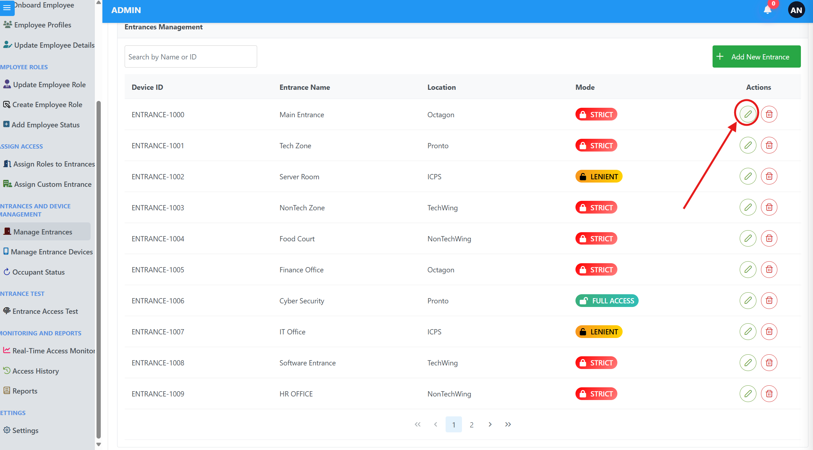  
1. A pop-up dialog would appear pre-filled with the details of the entrance you selected.

2.Edit the necessary information you want

3. Click on update.

## Deleting an Entrance

To delete an entrance, click on the dustbin icon shown in image img.18.3.

***Img.18.3***

1. 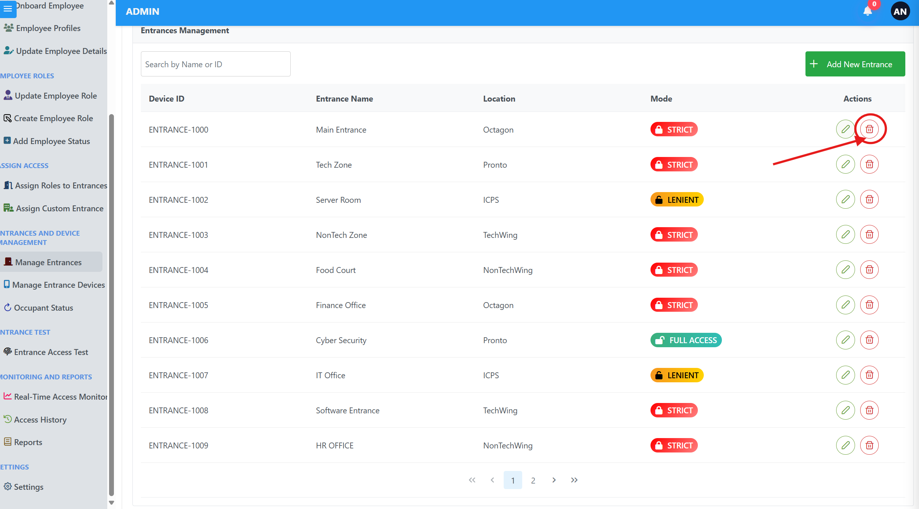
2. A pop-up dialogue would appear  
   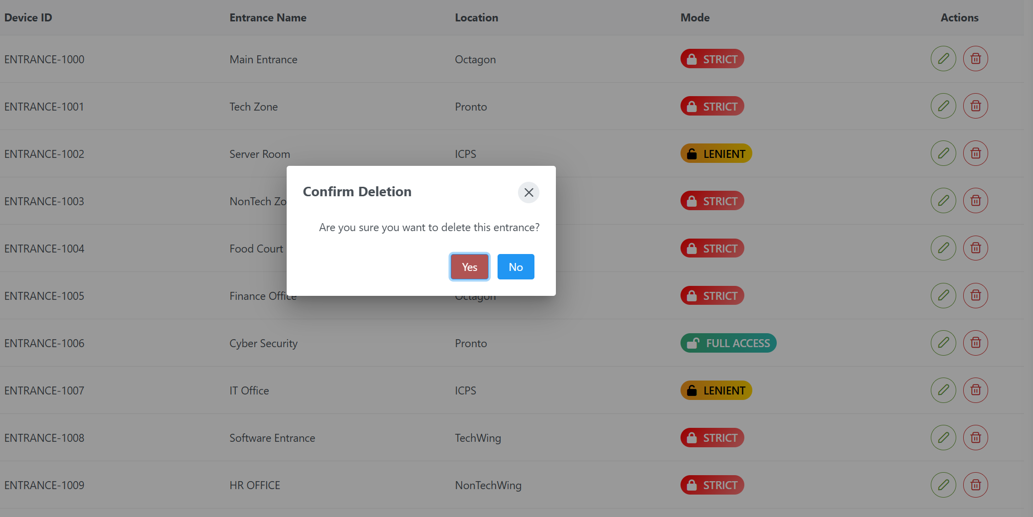
3. Click on Yes to delete the entrance.

# **ENTRANCE DEVICES MANAGEMENT**

**This page allows you manage and configure access devices for entrances**

To access this page, click on Manage Entrance Devices on the side Panel as shown in image Img 19.0.

***Img.19.0.***

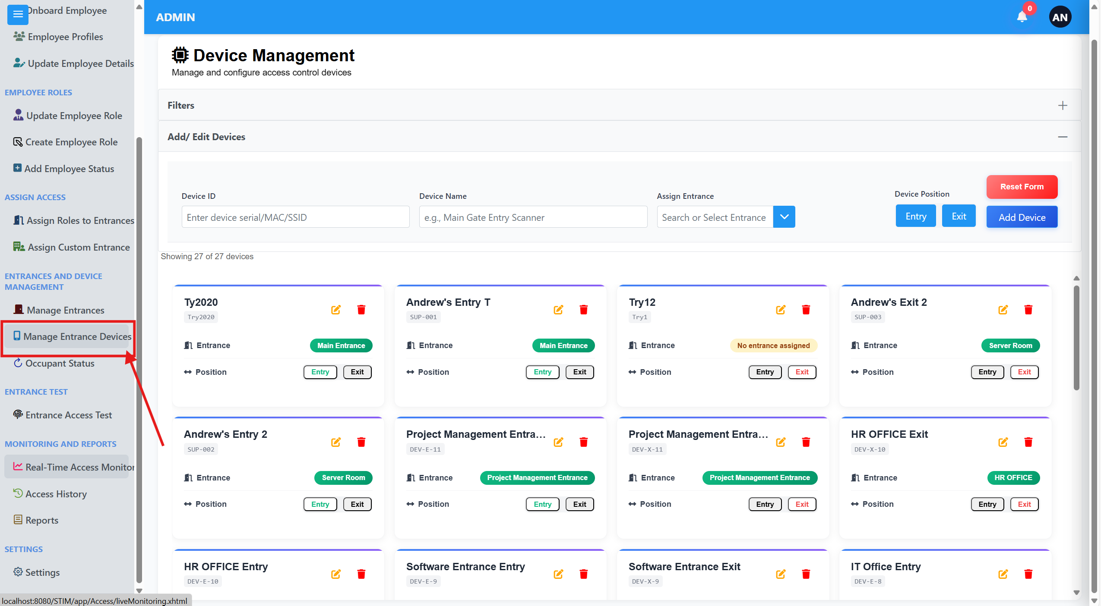

## Create new Device

1. Enter a new device ID
2. Enter the device name.
3. Click on the assign entrance dialogue and select an entrance from the dropdown.
4. Choose between an entry or exit for the device.
5. Click on add Device to successfully add a device.

## Edit a Device

1. Click on the pencil icon on the device you want to edit.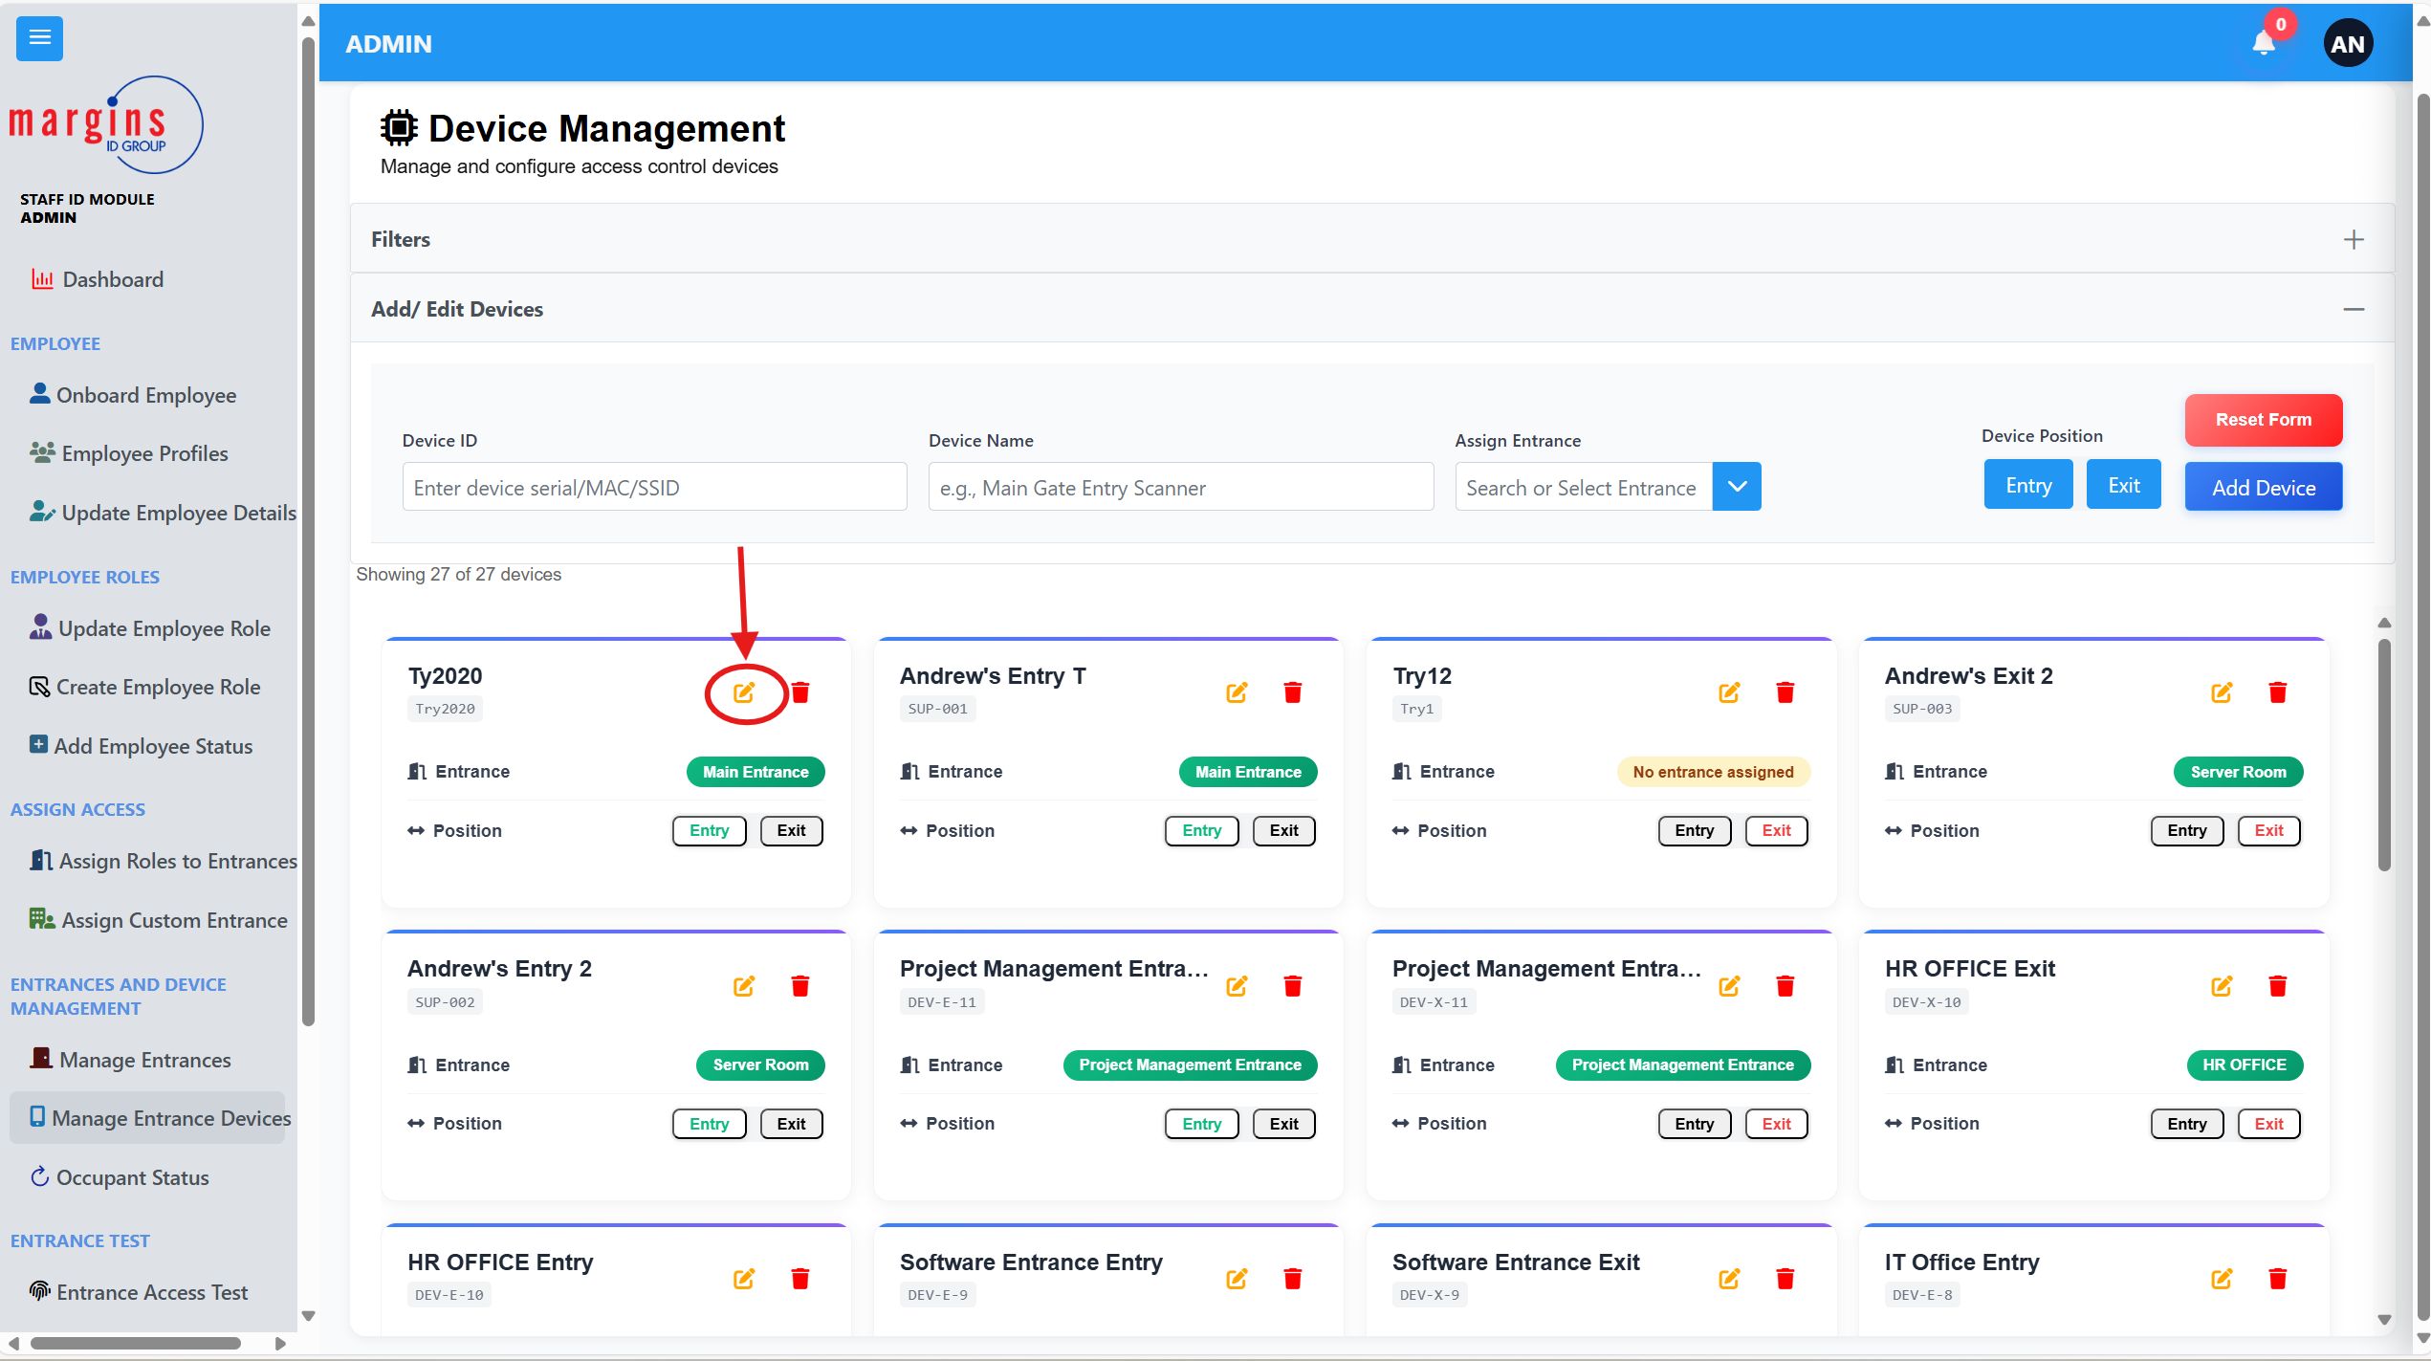
2. The selected devices data populates.  
   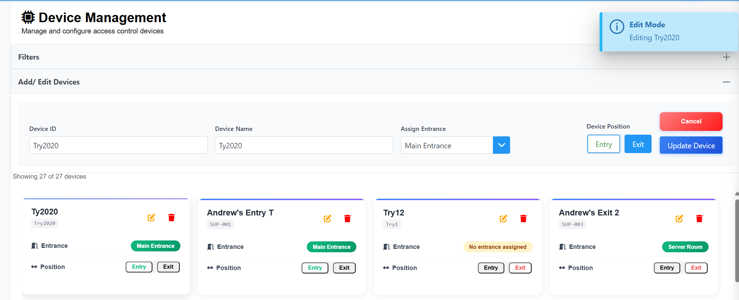
3. Edit the information you want
4. Click on update Device.

## Delete a device

To delete a device, click on the dustbin icon.

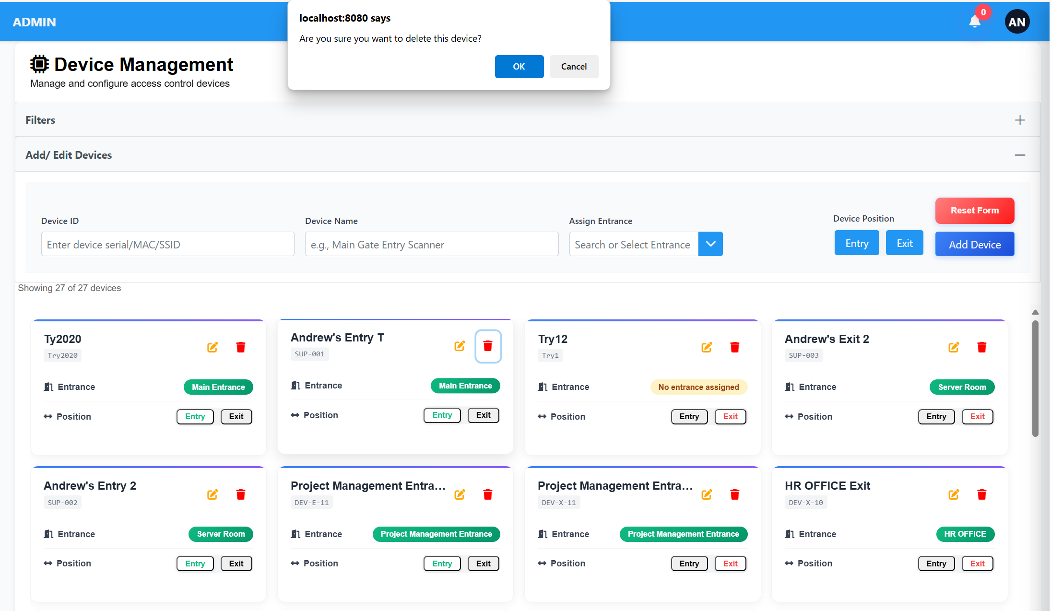

A pop-up dialog would show click on okay.

# **ROLE ACCESS CONFIGURATION**

To assign a role entrance they can access,

1. Click on the Assign Entrance to Roles tab

**Img.20.0**  
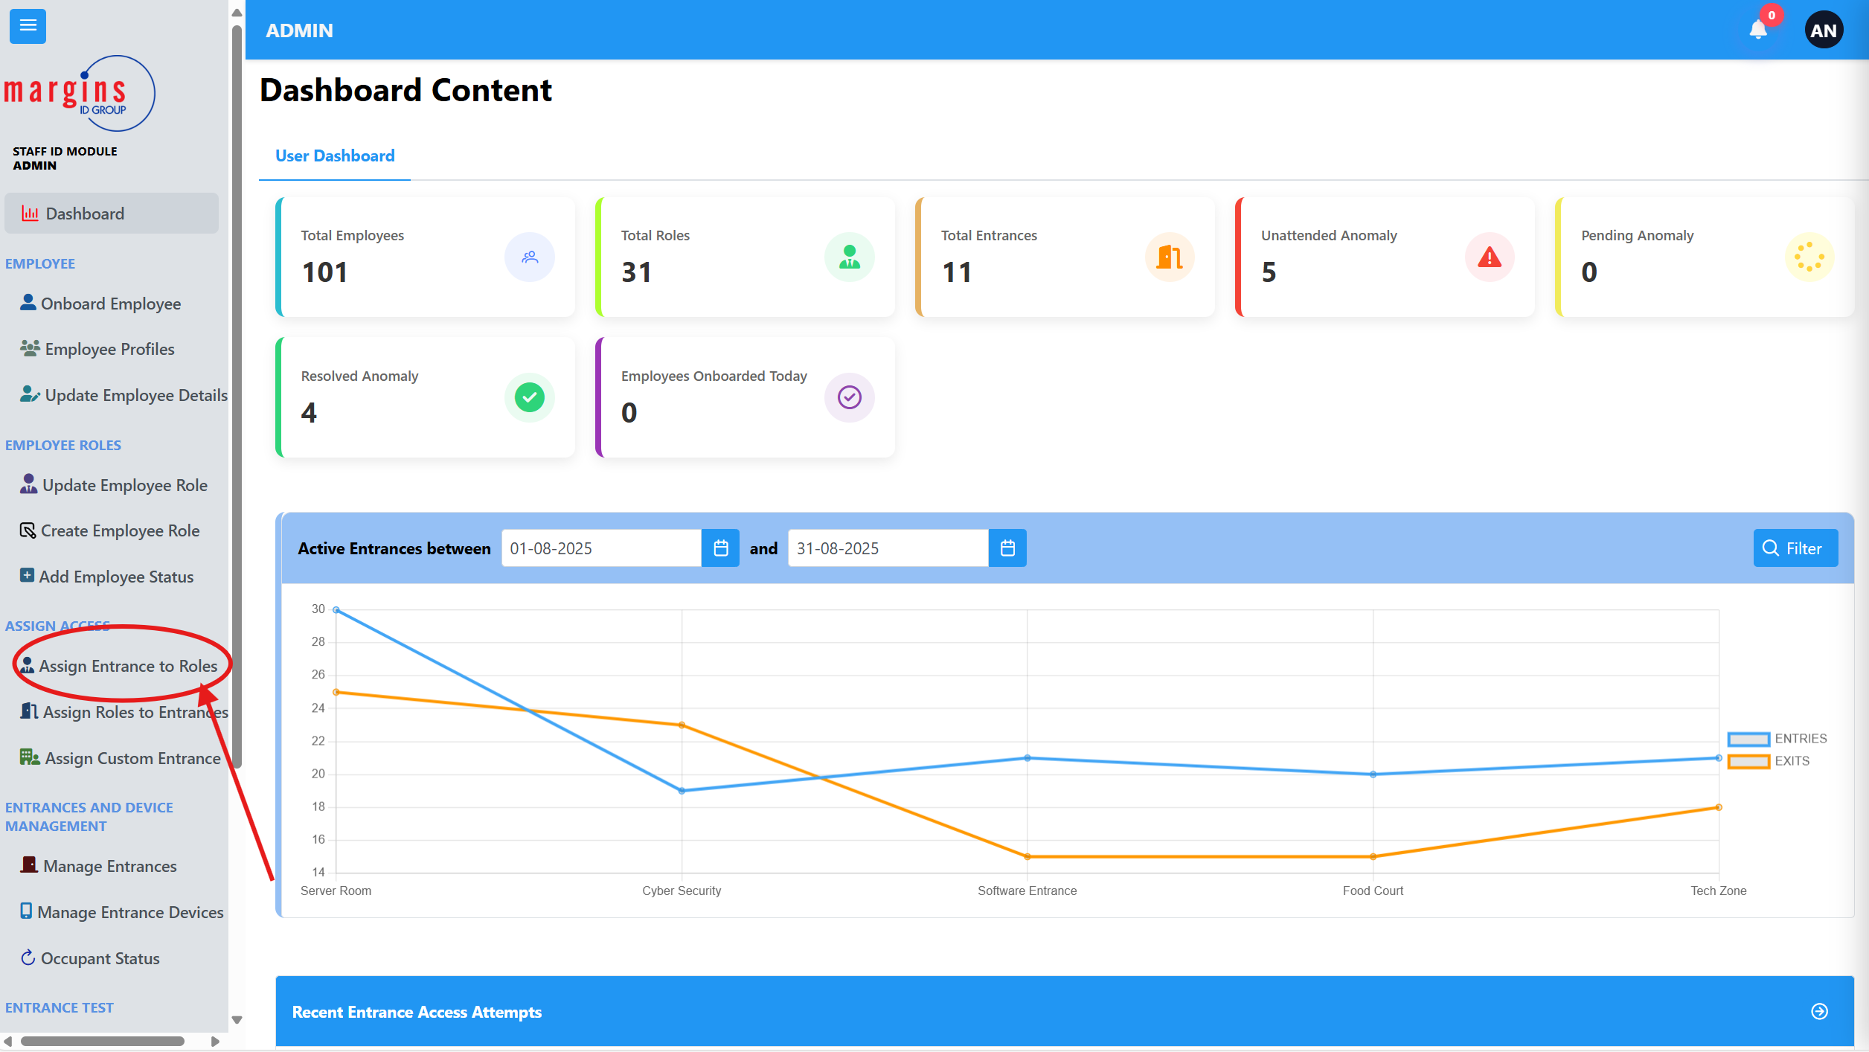

1. When the page loads click on the blue drop down button   
   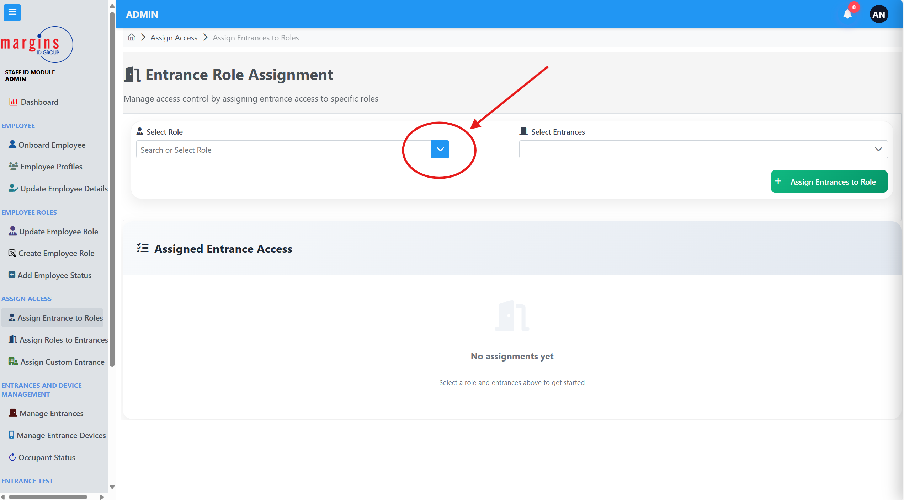
2. Select the role you want to configure,
3. The table below would load all entrances the entrance has access to.
4. To add more entrances, click on the select entrances dropdown as shown below  
   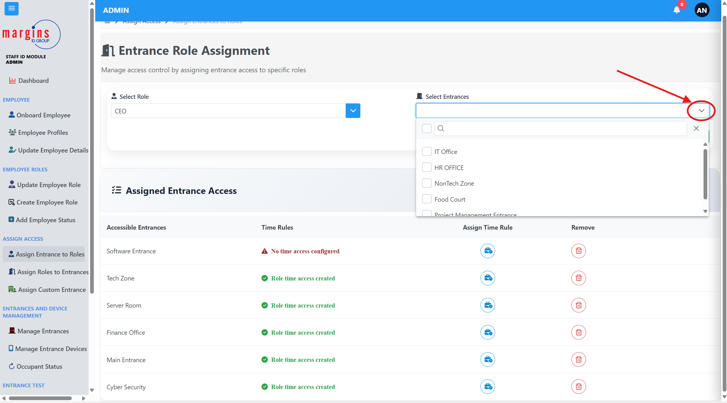
5. Select the entrance you want the selected Role to access
6. You can select as many entrances as you prefer.
7. Click on the assign button to assign the selected role access to the selected Entrances
8. 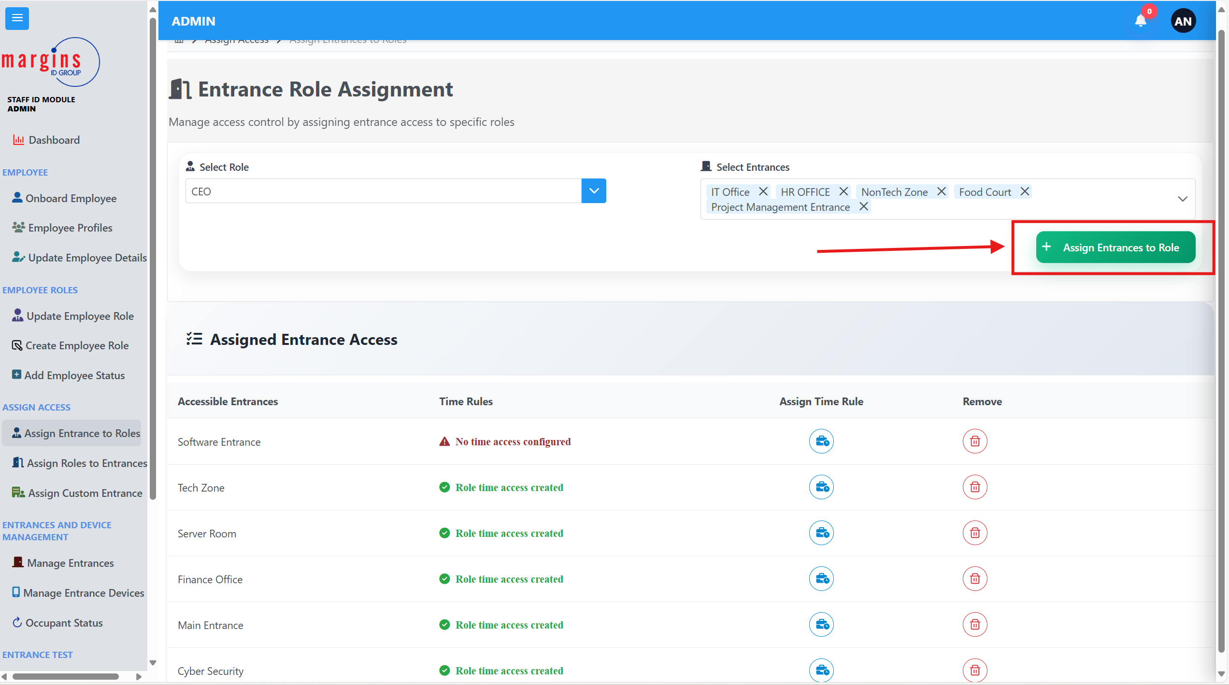

## Assigning Day and Time Access

This gives you the option of Assigning the specific days and times a person with that role can access that entrance.

To assign a time rule,

1. click on the blue Icon

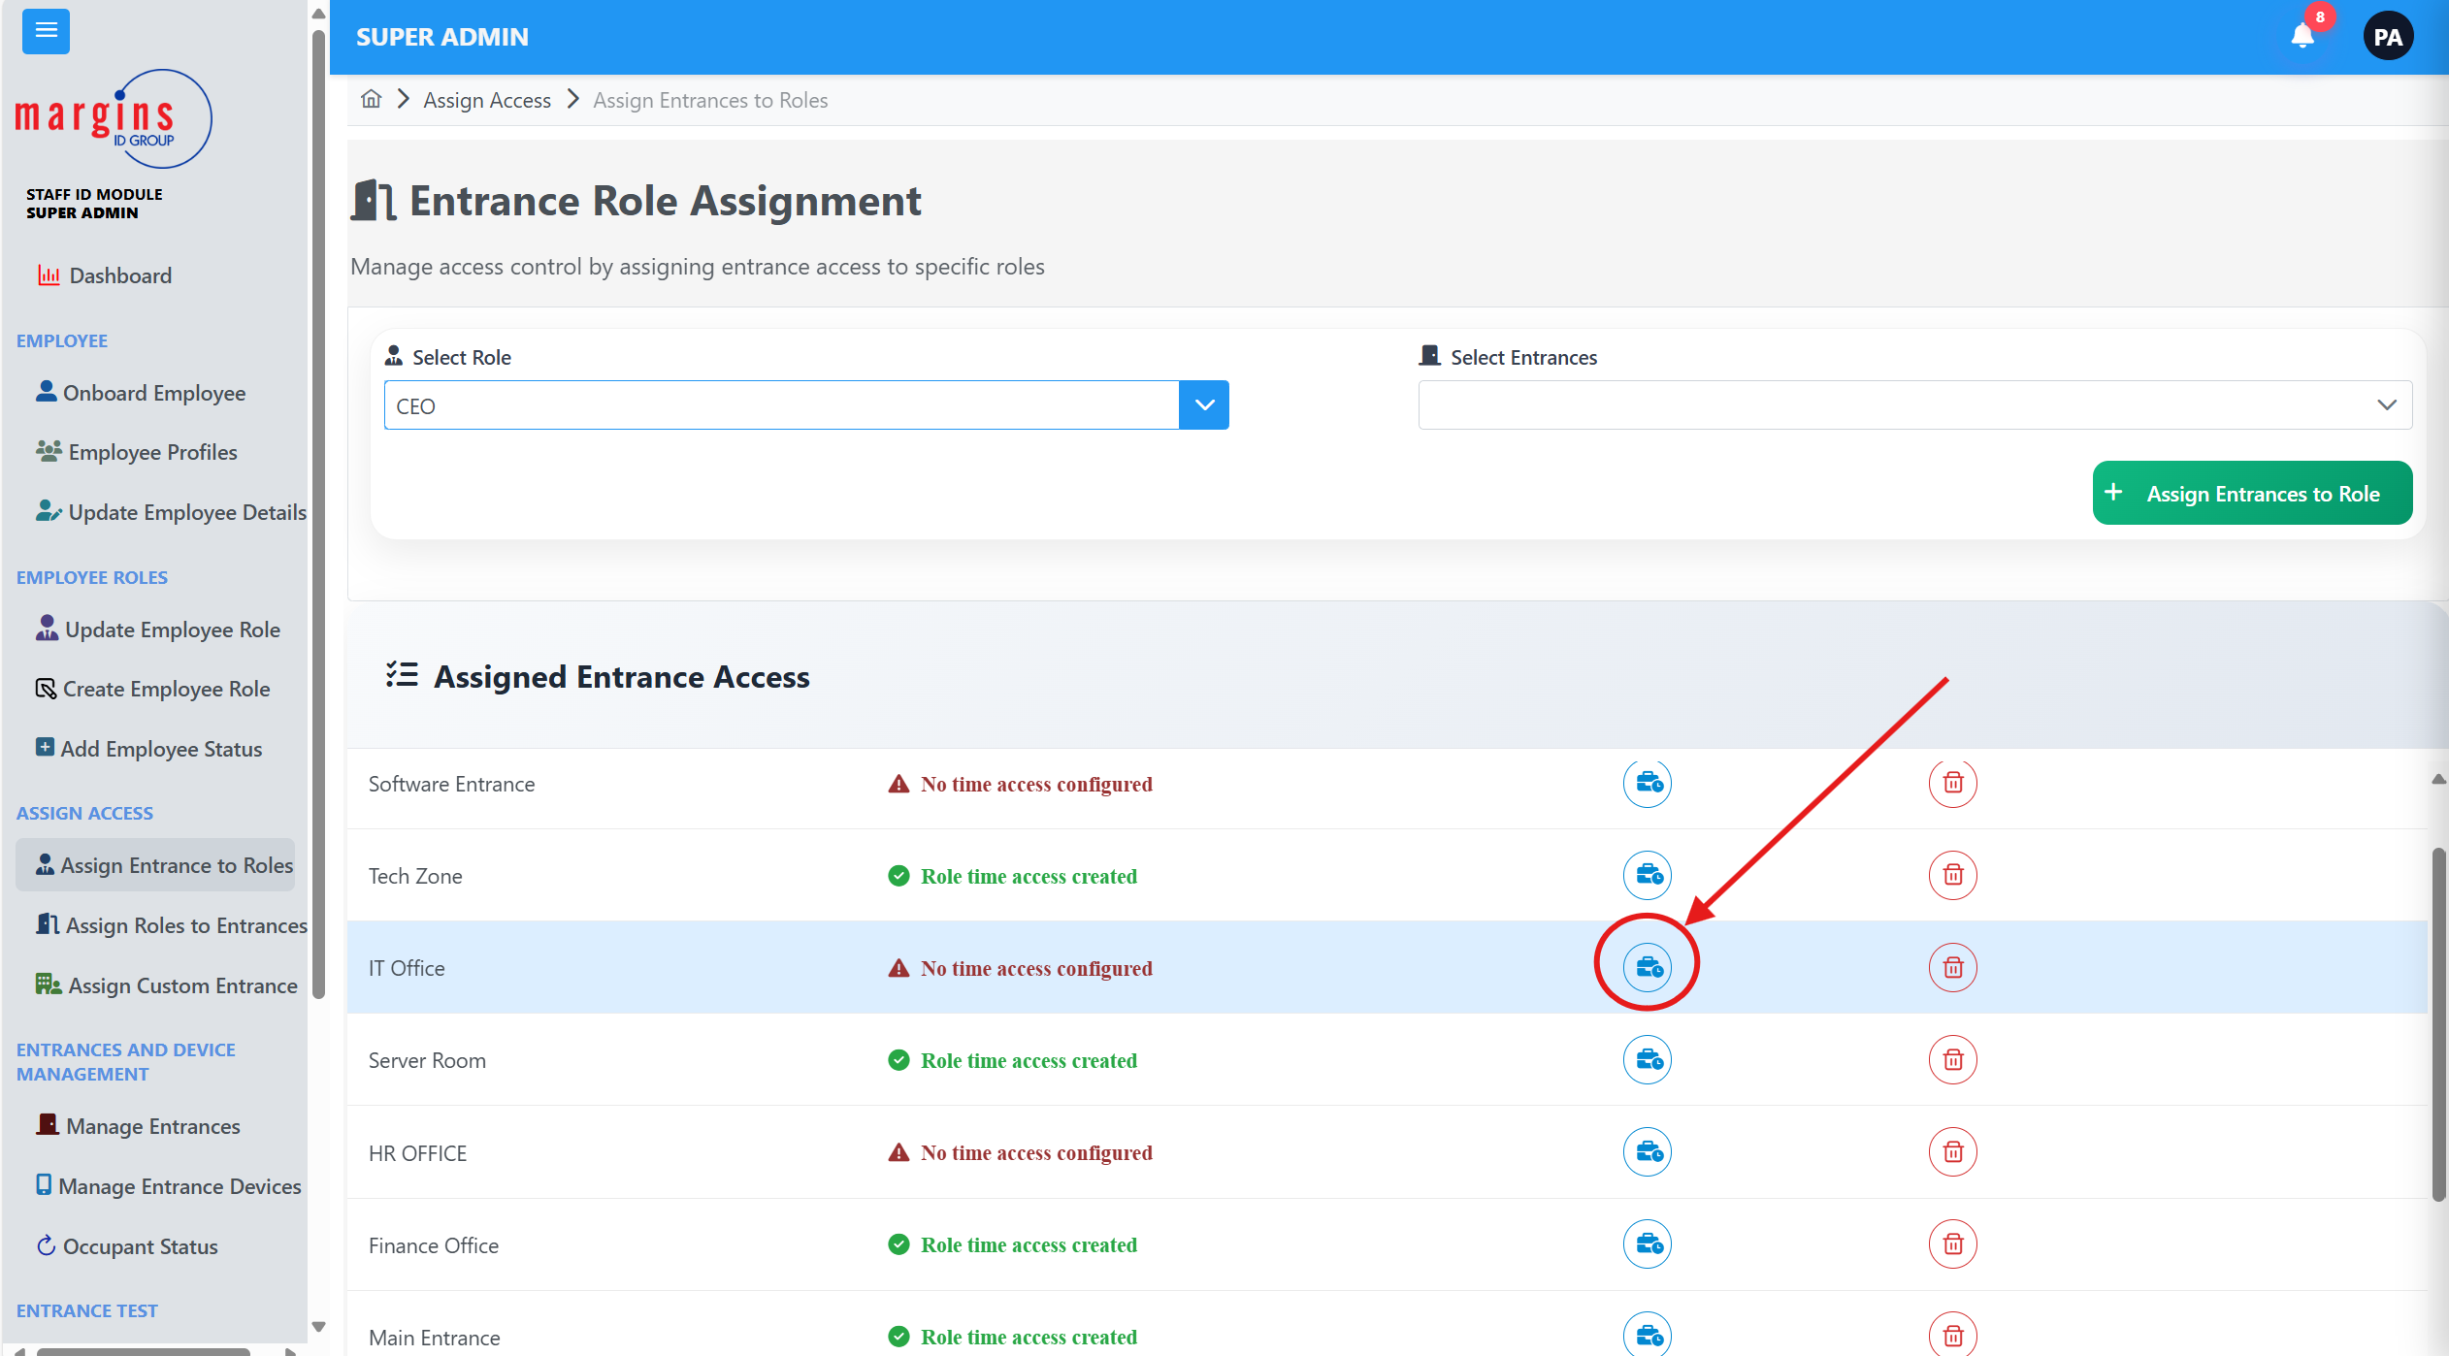

1. A side bar would appear.  
   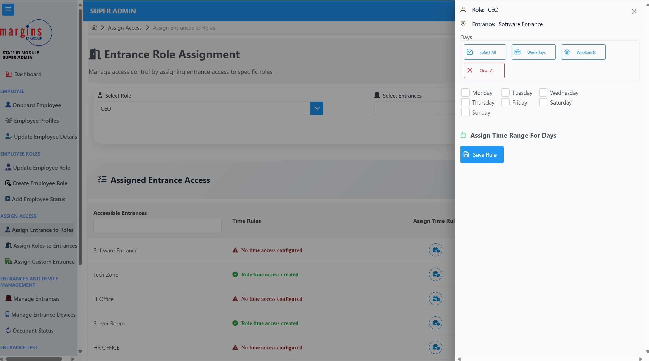
2. Select the day you want to assign for, a time range would show below.  
   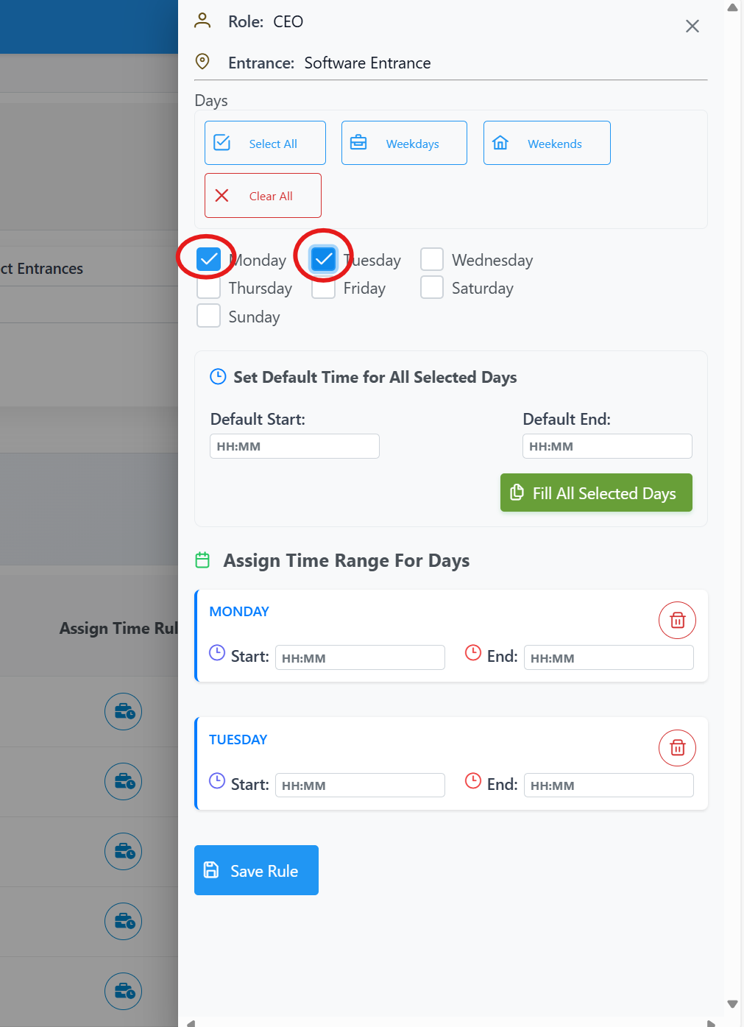
3. Select the time you want to assign and click on Save Rule.

## Assign Custom Entrance

**This page allows you to assign direct entrance access to employees.**

To access this page,

1. Click on the assign custom entrance on the sideBar  
   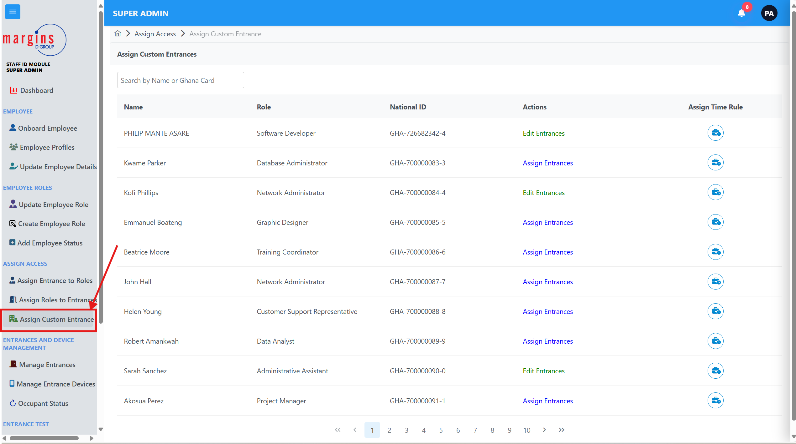
2. A list of employees would show
3. Click on Assign Entrance to Assign Entrances the employee has Access to
4. Click on Edit Entrance to update the current entrances the person has access to   
   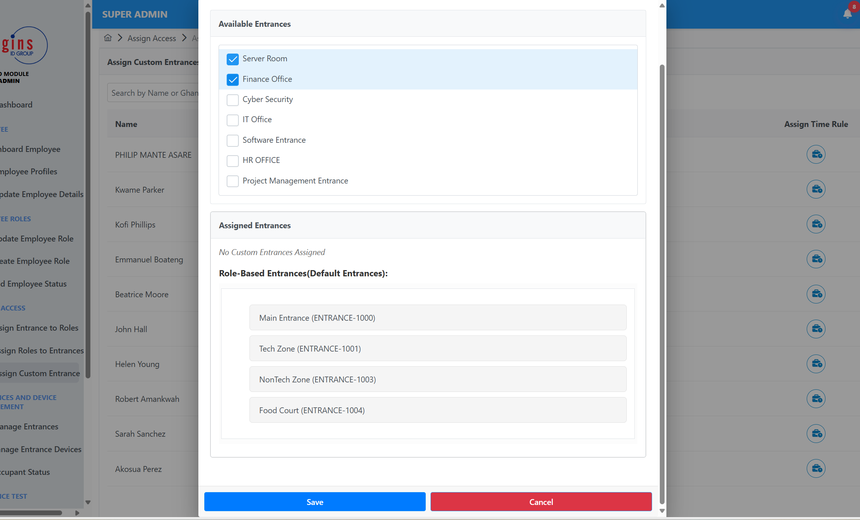
5. A pop-up dialogue would appear.
6. Select the entrances you want the employee to access
7. Click on Save to save it

## To Assign A Time Rule

1. Click on the assign time rule icon   
   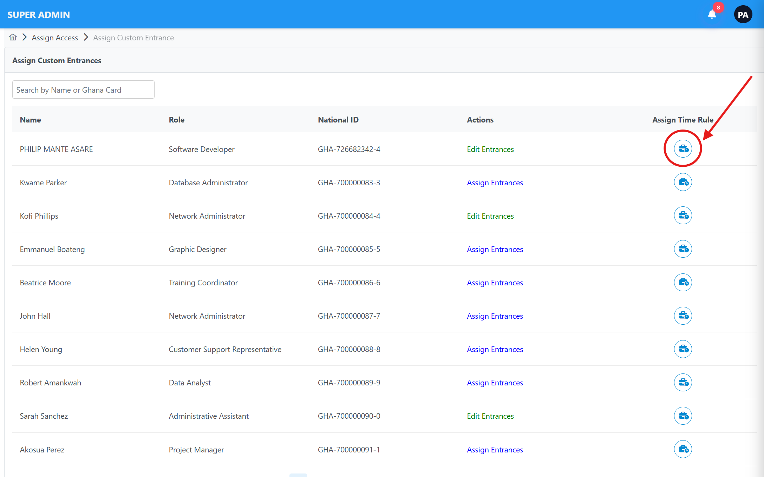
2. A sidebar would appear.
3. Click on the entrance drop down  
   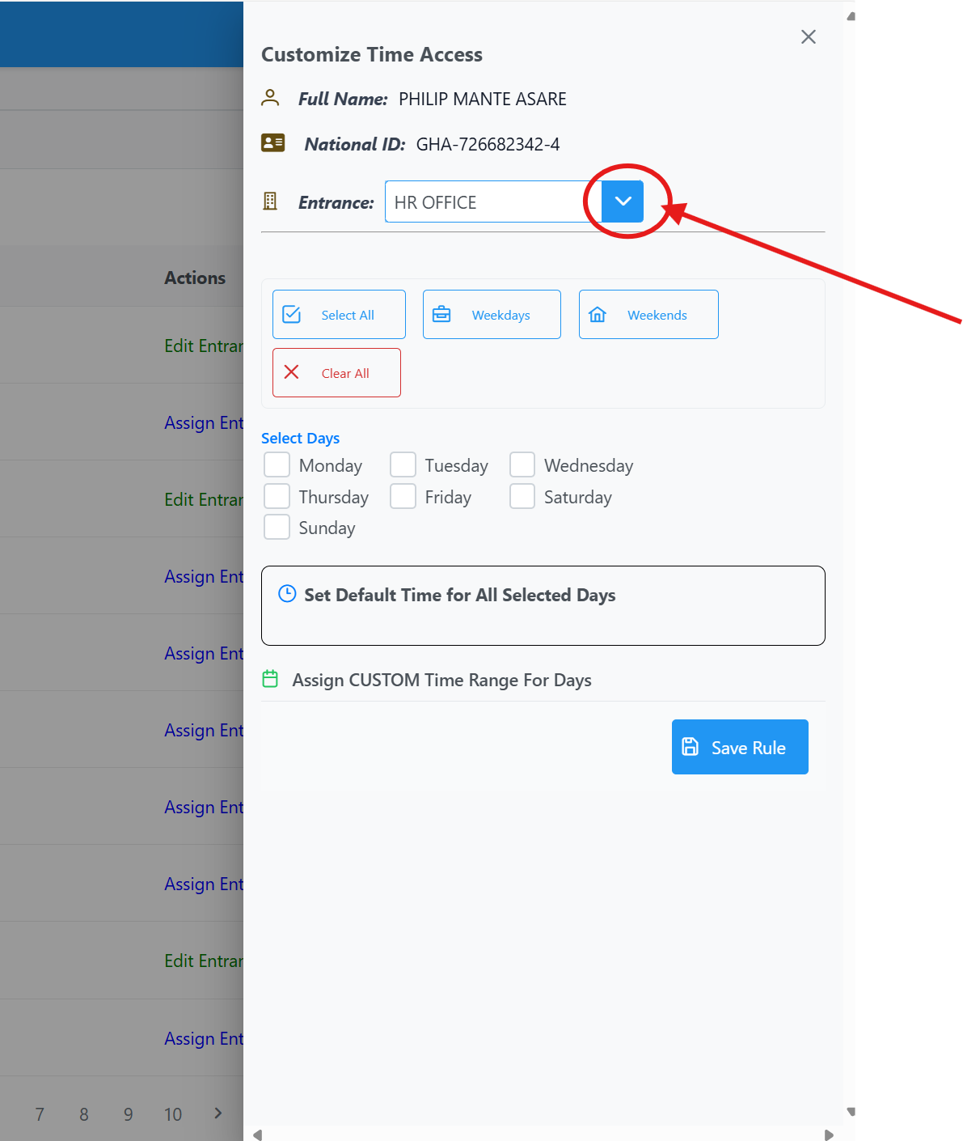
4. Select a day you want and assign a time range
5. Click on Save Rule.